Title:
Efficacy and Safety of Tegileridine fumarate versus other Opioid Analgesics for Acute Postoperative Pain: A GRADE-Assessed Systematic Review and Meta-Analysis of Randomized Controlled Trials
Authors:
Riya Bhagwanª, Sabahat Ul Ain Munir Abbasi^{b}, Neha Bhagwan Das^{c}, David Woode^{d}, Sandhiya Prem Kumar Lohana^{c}, Shiva Kumar ª, Archi Mehta ^{e}, Mahmood Mahboob Hassan^{b}, Preeti Advani ^{f}, Zain Ali^{g}, Kalpana Singh^{h}

Affiliations:
a: Dow University of Health Sciences Karachi, Pakistan
b: Allama Iqbal Medical College, Lahore, Pakistan
c: People's University of Medical and Health Sciences for Women, Nawabshah, Pakistan
d: Xavier University School of Medicine, Aruba
e: GMERS Medical College Gotri, Vadodara, Gujarat India-390021
f: Jinnah Sindh Medical University, Karachi, Pakistan
g: Rawalpindi Medical University, Rawalpindi, Pakistan
h: Hamad Medical Corporation, Doha, Qatar.

Corresponding Author:
Dr. Kalpana Singh
ORCID: 0000-0002-2273-5062
PhD, Senior Epidemiologist,
Hamad Medical Corporation, Doha, Qatar.
nkalpanasingh@gmail.com
Abstract
Background: Acute postoperative pain is common and can interfere with recovery and physical functioning. Although opioids remain widely used for postoperative analgesia, their use may be accompanied by adverse effects such as nausea, vomiting, and respiratory depression. Tegileridine fumarate is a novel partial μ-opioid receptor agonist that may provide effective analgesia with improved tolerability. We conducted this systematic review and meta-analysis to assess its efficacy and safety in postoperative pain management.
Materials and Methods: Following PRISMA guidelines 2020, PubMed/MEDLINE, Embase, Scopus, Cochrane, and ClinicalTrials.gov were searched from inception through 3rd July 2026. English-language RCTs enrolling adults undergoing any elective surgery and comparing tegileridine fumarate with other opioids were included. Primary outcomes were 24-hour resting summed pain intensity difference and patients requiring rescue analgesia in the first 24 hours. Analyses were performed using Review Manager 5.4 with risk ratios (RRs), mean differences (MDs), and 95% confidence intervals (CIs).
Results: Five RCTs, with six datasets, involving 1,181 participants were included. No significant difference was found in 24-hour resting summed pain intensity difference (MD = −0.62, 95% CI: −8.61 to 7.36; P = 0.88), although a fixed-effect sensitivity analysis favored tegileridine fumarate (MD = −3.82, 95% CI: −7.09 to −0.54; P = 0.02). Rescue analgesia requirements were similar between groups (RR = 1.02, 95% CI: 0.83–1.24; P = 0.88). There was reduced nausea (RR = 0.72, 95% CI: 0.54–0.96; P = 0.03), while vomiting showed borderline reduction (RR = 0.73, 95% CI: 0.53–1.00; P = 0.05). Additionally, no significant differences were observed for respiratory distress/desaturation, dizziness, or serious adverse events. Three studies had low overall heterogeneity, and GRADE certainty ranged from high to low.
Conclusion: Tegileridine fumarate was associated with a lower risk of nausea, while vomiting showed a borderline reduction, however there was no clear advantage in pain intensity or rescue analgesia requirements.
Keywords
Tegileridine fumarate; Opioids; Postoperative pain

Key Summary Points
- Five randomized controlled trials comprising 1,181 participants were included, comparing tegileridine fumarate with active opioid analgesics for acute postoperative pain.
- Tegileridine fumarate did not significantly improve 24-hour resting summed pain intensity difference or reduce rescue analgesia requirements compared with other opioid analgesics.
- Tegileridine fumarate significantly reduced the risk of nausea (RR 0.72, 95% CI 0.54–0.96), while vomiting showed a borderline reduction (RR 0.73, 95% CI 0.53–1.00).
- No significant differences were observed in respiratory distress/desaturation, dizziness, or serious adverse events, although the rarity of these events resulted in imprecise estimates.
- Overall, tegileridine fumarate provided broadly comparable analgesia with a potential gastrointestinal tolerability advantage, but larger, adequately powered multicenter trials are needed to establish its comparative efficacy and respiratory safety.

Introduction:
Approximately 80% of patients experience acute postoperative pain after surgery, which can adversely affect recovery, quality of life, increased risk of thromboembolic events, and physical functioning. ^{1,2} Inadequate postoperative pain management may delay hospital discharge and hinder early mobilization.³
Conventional opioids such as morphine, hydrocodone, and fentanyl remain widely used for postoperative pain management because of their established analgesic efficacy and availability in multiple formulations.⁴ However, their effects on β-arrestin-2 signaling have historically been implicated in opioid-related adverse effects, including gastrointestinal dysfunction, nausea, vomiting, and respiratory depression, which significantly reduces their therapeutic usefulness.⁵ and are common problems.⁶ Compared to unselective conventional opioids, a wider therapeutic window is created by a number of newly discovered opioids that modify µ-receptor activity by selectively engaging intracellular pathways associated with analgesia rather than those associated with adverse effects.²
Tegileridine fumarate is a novel biased agonist of the μ-opioid receptor developed for the management of acute postoperative pain. It is designed to preferentially activate G-protein-mediated signaling while minimizing β-arrestin-2 recruitment, potentially reducing opioid-related adverse effects while maintaining analgesic efficacy.⁷
This distinct signaling mechanism has been proposed to widen the therapeutic window of tegileridine fumarate, making it a viable option for managing postoperative pain.⁸ Preclinical research and early clinical trials have produced a body of evidence indicating the drug is both potentially safe and effective in producing analgesia.⁷ Tegileridine fumarate has been reported to have approximately ninefold greater analgesic potency than morphine on a morphine-equivalent dose basis.⁹ Although thorough safety data is still required, research suggest that tegileridine may have less opioid-related side effects than conventional opioids.¹⁰
However, clinical evidence regarding tegileridine fumarate remains limited and dispersed across randomized controlled trials evaluating different surgical populations, doses, and opioid comparators. Therefore, this systematic review and meta-analysis aimed to evaluate the efficacy and safety of tegileridine fumarate compared with other opioid analgesics for acute postoperative pain in adults undergoing surgery.

Methodology
Protocol Registration: This Systematic review and Meta-analysis was conducted and reported in accordance with the Preferred Reporting Items for Systematic Reviews and Meta-Analyses (PRISMA) 2020 criteria ¹¹. The review protocol was registered in the International Prospective Register of Systematic Reviews (PROSPERO)¹², under the registration number CRD420261450893. As all data were obtained from published literature, no ethical approval was required.
Study Selection: Eligible studies were identified searching PubMed/Medline, Embase, Scopus, Cochrane Central Register of Controlled Trials (CENTRAL), and ClinicalTrials.gov from inception to 3rd July 2026, using a combination of Medical Subject Headings (MeSH) and relevant terms in accordance with PICO framework. There was no restriction of time, date or language for the initial literature search. Detailed search strategy for each database is available in Supplemental table 1.
Inclusion Criteria: Eligibility criteria were established according to the PICO framework. Only randomized controlled trials enrolling adult patients undergoing elective surgical procedures were considered eligible. Studies were required to compare tegileridine fumarate with another opioid analgesic and report at least one relevant clinical outcome. Eligible opioid comparators included morphine, oxycodone, sufentanil, oliceridine, and other opioid analgesics administered for postoperative pain. Only articles published in English were included.
Exclusion Criteria: Studies were excluded if they fell outside the defined PICO framework, used non-randomized designs, involved animal models, or consisted of case reports, reviews, editorials, commentaries, or unpublished/non-peer-reviewed material such as conference abstracts. Pediatric studies and non-English publications were also excluded.
Screening Review: Following the literature search, all identified records were imported into Rayyan.ai for screening¹³. Duplicate records were detected and removed before the screening process. Two investigators screened titles and abstracts for eligible studies using Rayyan AI's blinded review feature, and subsequently full texts, applying the eligibility criteria. Discrepancies were resolved by discussion; or in adjunction with a third reviewer, when necessary. The selection process is illustrated in a PRISMA 2020 flow diagram as shown in Figure 1.
Data Extraction: Two reviewers independently extracted data, using a standardized electronic data extraction form created in Google Sheets, from all eligible studies after full-text assessment. For studies evaluating multiple doses, data from the highest eligible dose of tegileridine fumarate and the corresponding comparator dose were extracted to ensure a consistent approach to dose selection across studies, as no single standardized tegileridine dose was used across the included trials. Where distinct trial phases enrolled independent participant populations, each phase was treated as a separate dataset. Accordingly, the Phase II and Phase III cohorts reported by Zhao et al. (2025) were analyzed independently. All extracted data were cross-checked for accuracy, and any discrepancies were resolved through discussion, and consultation from a third reviewer when necessary. The extracted variables included:
Baselines/ study-level characteristics: author, year, country, study design, sample size, population/participant details, intervention and comparator details, outcome definitions and measures. Table 1
Outcomes: Resting summed pain intensity difference over 24 hours, patients requiring rescue analgesia in the first 24 hours, nausea, vomiting, dizziness, respiratory distress/ desaturation, and serious adverse effects.
For studies reporting medians and interquartile ranges, means and standard deviations were estimated using the Meta-Analysis Accelerator conversion calculator¹⁴.
Statistical Analysis: Statistical analyses were conducted using Review Manager (RevMan) version 5.4 developed by the Cochrane Collaboration¹⁵. Pooled analyses of dichotomous outcomes were performed using the Mantel–Haenszel method, with results expressed as risk ratios (RRs) and 95% confidence intervals (CIs). Continuous outcomes were synthesized as mean differences (MDs) with 95% confidence intervals (CIs). Forest plots were used to display graphically pooled estimates and their corresponding confidence intervals. Statistical significance was considered as a p-value of less than 0.05. Random-effects models were used for the primary meta-analyses because clinical and methodological heterogeneity was anticipated across surgical populations, intervention doses, opioid comparators, and outcome definitions. Fixed-effect models were used as sensitivity analyses to assess the robustness of pooled estimates to the choice of meta-analytic model.
Statistical heterogeneity among the included studies was evaluated using three complementary measures, Cochran’s Q test, the I² statistic, and Tau² (τ²). The extent of heterogeneity was quantified using the I² statistic, with values of approximately 25%, 50%, and 75% considered as representing low, moderate, and high heterogeneity, respectively¹⁶. In analyses indicating substantial heterogeneity, a leave-one-out sensitivity analysis was performed to assess the influence of individual studies on the overall effect estimate and heterogeneity.
When a study included multiple eligible opioid comparator arms, comparator groups were combined into a single control group to avoid double-counting participants. For dichotomous outcomes, event counts and sample sizes were summed across comparator arms. For continuous outcomes, means and standard deviations were combined using the methods recommended in the Cochrane Handbook.¹⁵
The meta-analysis compared tegileridine fumarate with other opioid analgesic comparators; therefore, placebo arms were excluded from all quantitative analyses. For Qiu et al. (2025), multiple eligible opioid comparator arms were present; the comparator groups were combined into a single control group in accordance with Cochrane recommendations¹⁵ to avoid double-counting participants and to permit a single pairwise comparison with the intervention group¹⁵. Sensitivity analyses excluding Qiu et al. (2025), the only included study incorporating oliceridine as an active comparator, were performed to assess the robustness of pooled estimates to the inclusion of this pharmacologically distinct comparator. Supplemental figure 1
Assessment of publication bias: Funnel plots and formal statistical tests for funnel plot asymmetry (Egger’s regression, Begg’s test) and trim-and-fill procedures were not performed because of fewer than ten included studies; as such tests are considered unreliable and may produce misleading results under these conditions according to the Cochrane recommendations.¹⁵
Quality Assessment: Risk of bias in the included trials was appraised independently by two reviewers using Cochrane Risk of Bias 2 (RoB 2) tool¹⁷. The tool structures judgement around five core domains including (1) bias arising from the randomization process; (2) bias due to deviations from intended interventions; (3) bias due to missing outcome data; (4) bias in the measurement of the outcome; (5) bias in the selection of the reported result Figure 2. Any disagreements were resolved by discussion or consultation with a third reviewer.
Certainty of Evidence: The certainty of evidence for each prespecified outcome was independently assessed using the Grading of Recommendations Assessment, Development and Evaluation (GRADE) framework¹⁸. Evidence from randomized controlled trials began at a rating of high certainty, with the possibility of being downgraded across five domains: risk of bias, inconsistency of results, indirectness of evidence, imprecision, and publication bias. Based on this assessment, the overall certainty of evidence was rated as high, moderate, low, or very low. Results are summarized in Supplemental Table 2

Results
Eligible Studies: The literature search identified sixty-one records from five databases and trial registries, of which thirty-four duplicate records were removed. Twenty-seven studies had remained for title and abstract screening. Of these, thirteen records were excluded. Fourteen studies were assessed for eligibility against the predefined inclusion criteria and ultimately five randomized controlled trials^{19, 20, 21, 22, 23} were included in the meta-analysis. Where independent trial phases represented distinct participant populations, these were treated as separate datasets for outcome-specific analyses¹⁹. The study selection process is illustrated in the PRISMA 2020 flow diagram Figure 1.
Study Characteristics: The total number of participants across the included trials was 1,181, comprising 611 participants in the tegileridine fumarate groups and 570 in the opioid comparator groups included in the quantitative analyses. The included trials evaluated tegileridine fumarate at different doses and administration regimens as an intervention. Opioid comparators included morphine, oxycodone, sufentanil, and oliceridine. Placebo arms were not included in the quantitative synthesis. The dosage and administration schedules of tegileridine fumarate varied across the included studies. Tegileridine was administered either as a weight-based continuous infusion (0.01 mg/kg), as a fixed bolus dose (0.05 mg), or as an intravenous loading dose followed by patient-controlled analgesia (PCA). Loading doses ranged from 0.75 to 1.0 mg, while PCA doses ranged from 0.05 to 0.2 mg depending on the study and treatment phase. All the patients included had an elective surgery and had acute postoperative pain. Zhao et al. 2025¹⁹ reported two phases of the trial, i.e. phase II and phase III, both were taken as two separate datasets as the patient population was different¹⁹. The male to female ratio in the intervention group was 210:401 while that in the control group was 192:378. All the included studies were conducted in China. The mean age of participants ranged from 30.44 to 58 years in the control group and 32.47 to 60 years in the tegileridine fumarate group. Detailed baseline characteristics, including age, sex, surgical procedure, intervention dose, comparator, and sample size, are presented in Table 1.
Risk of Bias Assessment: The risk of bias was assessed using the Cochrane Risk of Bias 2 (RoB.2)²⁴. Of the five included randomized controlled trials, three studies (Zhao et al., 2025; Wang et al., 2025; and Zheng et al., 2026) ^{19,20 ,23} were judged to have an overall low risk of bias, with low risk across all assessed domains. Qiu et al. (2025)²¹ was rated as having an overall high risk of bias due to high risk in the domain of selection of the reported result (D5) despite low risk in the remaining domains. Fu et al. (2026)²² was also judged to have an overall high risk of bias because of high risk in the selection of the reported result (D5) and some concerns regarding deviations from the intended intervention (D2). Overall, the methodological quality of the included studies was considered acceptable, with three of five studies demonstrating a low overall risk of bias and no study exhibiting high risk in the randomization process, missing outcome data, or outcome measurement Figure 2.
Certainty of evidence: The certainty of evidence, assessed using the GRADE approach, ranged from high to low across the evaluated outcomes. The certainty of evidence was high for nausea, moderate for patients requiring rescue analgesia within the first 24 hours, vomiting, and respiratory distress/desaturation, and low for resting summed pain intensity difference over 24 hours (rSPID24), dizziness, and serious adverse events. The detailed GRADE assessment for each outcome is presented in Table 2.

Primary Outcomes:
- Resting Summed Pain Intensity Difference over 24 Hours (rSPID24): Three studies^{19, 20,21} involving 558 participants were included, with Zhao et al. (2025)¹⁹ contributing two datasets. Of these, 270 participants received tegileridine fumarate and 288 received the control intervention. All three studies assessed resting summed pain intensity difference over 24 hours (rSPID24).The pooled analysis using a random-effects model demonstrated no statistically significant difference between the Tegileridine fumarate and control groups (MD = −0.62, 95% CI: −8.61 to 7.36; P = 0.88). There was substantial heterogeneity among the included studies (I² = 77%, χ² = 13.01, df = 3, P = 0.005). Figure 3.
Sensitivity analysis: In a fixed-effect sensitivity analysis, the pooled estimate favored tegileridine fumarate (MD −3.82, 95% CI −7.09 to −0.54; P = 0.02); however, this finding was not observed in the primary random-effects analysis, which demonstrated substantial heterogeneity. Supplemental Figure 2
Furthermore, in a leave-one-out sensitivity analysis excluding Qiu et al. (2025), which used oliceridine and morphine as the comparator, heterogeneity was reduced to 0% and the pooled estimate remained statistically nonsignificant (MD 3.38, 95% CI −1.80 to 8.57; P = 0.20). Supplemental Figure 1
- Patients requiring rescue analgesia in the first 24hrs: The requirement for rescue analgesia within the first 24 hours was reported across the same three randomized controlled trials^{19,20, 21} There were 99 patients requiring rescue analgesia in the tegileridine fumarate group compared with 111 patients in the control group. Meta-analysis using a random-effects model demonstrated no statistically significant difference in the risk of requiring rescue analgesia within the first 24 hours between the tegileridine fumarate and control groups (RR=1.02, 95% CI: 0.83–1.24; P=0.88). There was no evidence of heterogeneity (I²=0%, χ²=2.19, df=3, P=0.53) Figure 4.
Sensitivity analysis: Leave-one-out sensitivity analysis excluding Qiu et al. (2025) showed no statistically significant difference between the groups (RR = 1.00, 95% CI: 0.77–1.30; P = 0.99), with low heterogeneity (I² = 7%). Supplemental Figure 3

Secondary Outcomes:
- Vomiting: Three randomized controlled trials^{19,20,21}, contributing four datasets, involving 555 participants reported vomiting. There were 50 vomiting events among 276 patients receiving tegileridine fumarate and 71 events among 279 patients receiving other opioid analgesics. The pooled analysis demonstrated a borderline statistically significant reduction in the risk of vomiting with tegileridine fumarate compared with other opioid analgesics (RR = 0.73, 95% CI: 0.53 -- 1.00; P = 0.05). Heterogeneity was negligible (I² = 0%, χ² = 2.74, P = 0.43) Figure 5.
- Nausea: The same three randomized controlled trials^{19,20,23}, contributing four datasets, reported nausea as an adverse event. There were 58 adverse events in the tegileridine fumarate group compared with 79 events in the control group. Meta-analysis using a random-effects model demonstrated statistically significant reduction in the risk of nausea between the tegileridine fumarate compared with the control group (RR=0.72, 95% CI: 0.54-0.96; P=0.03). There was no evidence of heterogeneity (I²=0%, χ²=1.60, df=3, P=0.66) Figure 6.
- Respiratory Distress/ Desaturation: Five randomized controlled trials^{19–23}, contributing six datasets, involving 698 participants (339 receiving tegileridine fumarate and 359 receiving other opioid analgesics), evaluated respiratory distress/desaturation as an adverse event. Three of the six datasets reported no events in either treatment arm and therefore did not contribute an estimable effect estimate to the meta-analysis. Across the three estimable datasets, there were six events in the tegileridine fumarate group and five events in the other opioid analgesic group. The pooled analysis using a random-effects model demonstrated no statistically significant difference between the groups (RR = 1.33, 95% CI: 0.43–4.17; P = 0.62). Heterogeneity was negligible (I² = 0%, χ² = 1.98, df = 2, P = 0.37) Figure 7.
Sensitivity analysis: Leave-one-out sensitivity analysis excluding Qiu et al. (2025) yielded the same pooled estimate, with no statistically significant difference between the groups and no evidence of heterogeneity. Supplemental Figure 4
- Dizziness: Three randomized controlled trials^{19, 22, 23}, with four datasets, involving 360 participants (178 receiving tegileridine fumarate and 182 receiving other opioid analgesics) reported dizziness as an adverse event. There were seven dizziness events in the tegileridine fumarate group compared with five events in the control group. Meta-analysis using a random-effects model demonstrated no statistically significant difference in the risk of dizziness between the tegileridine fumarate and control groups (RR=1.25, 95% CI: 0.41–3.77; P=0.70). There was no evidence of heterogeneity (I²=0%, χ²=1.60, df=3, P=0.66). Figure 8
- Serious Adverse Events: Two randomized controlled trials, with three datasets,^{19,20} involving 483 participants (240 in the tegileridine fumarate group and 243 in the control group) evaluated serious adverse events. There was one serious adverse event in the tegileridine fumarate group compared with two events in the control group. There was no statistically significant difference between the two groups (RR=0.71, 95% CI: 0.11–4.43; P=0.71). There was no evidence of heterogeneity among the included studies (I²=0%, χ²=1.21, df=2, P=0.55). Figure 9

Discussion
Acute postoperative pain remains inadequately controlled in a substantial proportion of surgical patients, and opioids remain the mainstay of moderate-to-severe pain management despite a well-characterised burden of opioid-related adverse effects, including nausea, vomiting, gastrointestinal dysfunction, and respiratory depression²⁵.
The rationale for biased µ-opioid receptor (MOR) agonists rests on the receptor engaging two downstream effectors — G_{i/o} proteins, which mediate analgesia, and β-arrestin-2, historically implicated in respiratory and gastrointestinal adverse effects. Ligands that preferentially engage G protein signalling are therefore hypothesised to preserve analgesia while reducing these harms ^{26.27}. This concept was realised clinically in Oliceridine, which provides morphine-comparable analgesia with fewer opioid-related adverse events²⁸. Tegileridine (SHR8554), approved in China in 2024²⁹, activates β-arrestin-2 at only around 10% of the level induced by morphine. Notably, the premise itself is contested: recent evidence suggests both pathways contribute to adverse effects³⁰, and some reported advantages of biased ligands may reflect low intrinsic efficacy rather than true bias³¹, underscoring the need to test whether Tegileridine's theoretical safety advantages are realised in practice.
Although Oliceridine established both a mechanistic and a regulatory precedent for this class²⁸, clinical evidence for Tegileridine has accrued only recently and across heterogeneous surgical settings, with individual trials differing in comparator, dose, and surgical model. We therefore conducted this systematic review and meta-analysis of five randomized controlled trials, evaluating the efficacy and safety of Tegileridine fumarate versus other opioid analgesics for acute postoperative pain in adults, and graded the certainty of evidence using the GRADE framework.
For the primary efficacy outcome — the resting summed pain intensity difference over 24 hours (rSPID₂₄) — the pooled random-effects analysis demonstrated no statistically significant difference between Tegileridine and other opioid analgesics, accompanied by substantial heterogeneity. A leave-one-out analysis excluding Qiu et al. (2025)²¹ reduced heterogeneity to zero while leaving the conclusion of no significant difference unchanged, suggesting that Qiu et al. contributed substantially to the observed between-study heterogeneity. This is mechanistically plausible: Qiu et al. was the only trial to employ oliceridine, a G-protein-biased μ-opioid receptor agonist, as a comparator, and was also the only trial conducted in a thoracic minimally invasive esophagectomy population with co-administered multimodal paravertebral analgesia. These differences may explain its influence on between-study heterogeneity.
These findings warrant careful comparison with a recent meta-analysis by Yuan et al. (2026) ³², which pooled an overlapping set of trials but stratified analyses by dose and evaluated tegileridine against placebo and morphine separately rather than combining opioid comparators. In their morphine-specific comparison, Tegileridine was significantly inferior at rSPID24 (MD 5.41, 95% CI 2.50 to 8.33; P = 0.0003), yet comparable at rSPID12. The divergence from our own null primary result is largely methodological: pooling different opioid comparators may have produced an overall estimate that differs from morphine-specific analyses because individual opioids differ in pharmacological properties, dosing, and adverse-effect profiles. Our fixed-effect sensitivity analysis, in fact, yielded a small effect favouring Tegileridine. Taken together, the two syntheses are best reconciled as indicating that tegileridine provides analgesia broadly in the range of other opioid analgesics, with the possibility of a difference relative to morphine at 24 hours that remains sensitive to comparator definition and statistical model rather than establishing robust clinical inferiority. Unlike the recent review by Yuan et al., which primarily evaluated tegileridine against placebo and morphine with dose-stratified analyses, the present review specifically evaluates Tegileridine against active opioid analgesic comparators, including morphine, oxycodone, sufentanil, and oliceridine.
Consistent with the efficacy findings, the proportion of patients requiring rescue analgesia within the first 24 hours did not differ between Tegileridine and other opioids, with no observed heterogeneity, reinforcing the interpretation that the two treatment groups demonstrated no statistically significant difference in the need for rescue analgesia during the first 24 hours.
The most consistent safety signal was observed for gastrointestinal adverse effects, with lower risks of nausea and vomiting in the Tegileridine group. Nausea was significantly less frequent with Tegileridine than with other opioid analgesics, and vomiting showed a reduction of borderline significance; both outcomes were free of heterogeneity. These directionally concordant reductions are biologically coherent with the attenuated β-arrestin-2 engagement of Tegileridine and echo both the gastrointestinal tolerability advantage reported for oliceridine²⁸ and the morphine-specific reduction in nausea and vomiting observed by Yuan et al. (RR 0.86; P = 0.03)³². Because nausea is a subjective symptom whereas vomiting is an objective sign, the convergence of both toward benefit suggests a consistent gastrointestinal safety signal that warrants further investigation.
In contrast, respiratory distress or desaturation — the adverse effect of greatest theoretical interest for a β-arrestin-2–sparing opioid — showed no significant difference between groups. This null result should be interpreted as an absence of evidence rather than evidence of absence. Respiratory events were rare across all trials (six in the Tegileridine arm and five in the control arm among nearly 700 patients), and the contributing studies routinely administered prophylactic supplemental oxygen — a co-intervention that suppresses measurable desaturation and obscures any true between-group difference. The same limitation was noted by Yuan et al., who were unable to pool a Tegileridine-versus-placebo comparison for this outcome and cautioned that the available data are substantially underpowered³³. Given that the respiratory safety advantage is the central promise of the biased-agonist mechanism — and that this premise itself remains debated ^{30,31} — its confirmation remains an important unmet objective, and standard respiratory monitoring should be maintained pending adequately powered evidence.
Dizziness did not differ between groups, and serious adverse events were rare and comparable across arms, with no heterogeneity in either analysis. The very small number of serious events (one in the Tegileridine arm and two in the control arm across 483 patients) renders this estimate imprecise, but the absence of any excess of serious harm is reassuring and consistent with the individual trials, none of which reported treatment-related deaths attributable to Tegileridine.
Taken together, these findings support a coherent overall picture: Tegileridine provides analgesia broadly comparable to other opioid analgesics while conferring a modest but consistent reduction in gastrointestinal adverse effects. No statistically significant differences were observed for the evaluated safety outcomes, although estimates for rare events were imprecise.
This benefit-risk profile is that predicted by the biased-agonism hypothesis^{26.27}, and positions Tegileridine as a potentially useful option for acute postoperative pain, particularly in patients at elevated risk of opioid-induced nausea and vomiting — though the certainty of this evidence is constrained by the limitations detailed below.
Strengths and limitations: This review has several strengths. To our knowledge it is among the first quantitative syntheses of the randomized evidence for Tegileridine in acute postoperative pain, and it was conducted in accordance with PRISMA 2020, with duplicate independent screening and data extraction, Cochrane RoB 2 risk-of-bias assessment, and GRADE certainty rating for each outcome. By restricting comparisons to other opioid comparators and excluding placebo arms, the pooled estimates reflect clinically meaningful head-to-head contrasts. Where trials evaluated multiple doses, the highest dose of both intervention and comparator was extracted, and the two independent phases of Zhao et al. (2025) ¹⁹ were treated as separate datasets to respect their distinct patient populations. Our combined-comparator approach also complements the dose-stratified analysis of Yuan et al.³², and the broad concordance between the two syntheses on the gastrointestinal and respiratory outcomes lends robustness to those conclusions.
Several limitations temper these conclusions. At the level of the evidence base, only five trials met eligibility, and most outcomes were informed by four or fewer datasets, yielding wide confidence intervals and, for the primary efficacy outcome, substantial heterogeneity attributable chiefly to a single trial that differed in comparator and surgical model. The instability of the primary efficacy estimate across statistical models — and its divergence from the morphine-specific inferiority reported elsewhere³² — indicates that the magnitude of any analgesic difference remains uncertain. At the level of the interventions and outcomes, the included trials varied in surgical setting, comparator agent, and dose, and the near-universal use of prophylactic oxygen precluded meaningful assessment of respiratory safety, the outcome for which the biased-agonist mechanism offers the strongest theoretical rationale but for which the underlying premise itself remains debated^{30,31}. Rare events left the serious-adverse-event and respiratory analyses underpowered. Two of the five trials were judged to be at high overall risk of bias, driven principally by concerns in selective reporting, and formal assessment of publication bias was not undertaken because fewer than ten studies were available. Finally, every trial was conducted in China in predominantly Han Chinese populations, which may limit generalizability, since opioid response and adverse-event rates can differ across ethnic and pharmacogenetic backgrounds and some perioperative practices in these trials reflect Chinese clinical norms.
Accordingly, these estimates should be regarded as an early, provisional synthesis, and adequately powered multicenter trials—ideally with standardized comparators, protocols permitting genuine evaluation of respiratory safety, and longer follow-up—are required to further clarify the comparative analgesic efficacy and gastrointestinal safety profile of Tegileridine.

References
1 Werner M.U., Søholm L., Rotbøll-Nielsen P., Kehlet H. Does an acute pain service improve postoperative outcome? Anesth Analg. 2002;95:1361–1372. doi: 10.1097/00000539-200211000-00049. table of contents [PMID: 12401627. [DOI] [PubMed] [Google Scholar]
2 Gan T. J. (2017). Poorly controlled postoperative pain: prevalence, consequences, and prevention. Journal of pain research, 10, 2287–2298. https://doi.org/10.2147/JPR.S144066
3 Shi, Z., Li, M., Ran, B., & Yu, L. (2013). Gabapentin and Pregabalin in the Management of Postoperative Pain After Lumbar Spinal Surgery: A Systematic Review and Meta-analysis. Spine, 38(22), 1947–1952. https://doi.org/10.1097/BRS.0b013e3182a69b90)
4 Violin, J. D., Crombie, A. L., Soergel, D. G., & Lark, M. W. (2014). Biased ligands at G-protein-coupled receptors: promise and progress. Trends in pharmacological sciences, 35(7), 308-316.
5 Yuan, Y., Xu, T., Huang, Y., & Shi, J. (2024). Strategies for developing μ opioid receptor agonists with reduced adverse effects. Bioorganic Chemistry, 149, 107507.
6 Gupta, A., Mena, S., Jin, Z., Gan, T. J., & Bergese, S. D. (2021). Postoperative pain: a review of emerging therapeutic options. Expert Review of Neurotherapeutics, 21(10), 1085–1100. https://doi.org/10.1080/14737175.2021.1974840
7 Xu, H., Lu, F., Wang, Y., Ruan, X., Xie, H., & Zhong, M. (2026). Determination of the ED50 of Tegileridine and Comparison with Fentanyl for Analgesia During Hysteroscopy in Chinese Female Patients: An Exploratory Sequential Dose-Finding Study. Drug design, development and therapy, 20, 608163. https://doi.org/10.2147/DDDT.S608163
8 Mugabure Bujedo, B., & González Santos, S. (n.d.). Nuevos Opioides Con Diferente Mecanismo De Acción Intracelular; ¿una Nueva Ventana Terapéutica Se Abre Ante Nosotros? https://doi.org/10.20986/resed.2021.3891/2021
9 Fu, Y., Chen, X., Gao, F. P., Liang, Y., Wang, D. Y., Chen, C. Q., & Sun, H. (2026). Tegileridine, a Biased μ-Opioid Receptor Agonist, versus Oxycodone for Postoperative Analgesia and Postoperative Nausea and Vomiting After Total Laparoscopic Hysterectomy: A Randomized Double-Blind, Single-Center, Controlled Trial. Drug design, development and therapy, 20, 598457. https://doi.org/10.2147/DDDT.S598457
10 Feng, Y., Yang, G., Zhang, P., Li, L., Tian, J., Wang, Y., & Chu, Q. (2025). The Analgesic Effect of Tegileridine in Older Adult Patients After Laparoscopic Abdominal Tumor Surgery: Study Protocol for a Randomized Controlled Trial. Pain and Therapy, 15, 433–441. https://doi.org/10.1007/s40122-025-00798-4
11 https://link.springer.com/article/10.1186/s13643-021-01626-412 https://www.crd.york.ac.uk/PROSPERO/view/CRD420261450893
13 Ouzzani M, Hammady H, Fedorowicz Z, Elmagarmid A. Rayyan-a web and mobile app for systematic reviews. Syst Rev. 2016 Dec 5;5(1):210. doi: 10.1186/s13643-016-0384-4. PMID: 27919275; PMCID: PMC5139140
14 Abbas A, Hefnawy MT, Negida A. Meta-analysis accelerator: a comprehensive tool for statistical data conversion in systematic reviews with meta-analysis. BMC Med Res Methodol. 2024;24(1):1-11. doi:10.1186/s12874-024-02356-6.
15. Higgins JPT, Thomas J, Chandler J, Cumpston M, Li T, Page MJ, et al, editors. Cochrane Handbook for Systematic Reviews of Interventions version 6.5 (updated August 2024). Cochrane; 2024. Available from: https://www.cochrane.org/handbook.
16 Higgins JPT, Thompson SG, Deeks JJ, Altman DG. Measuring inconsistency in meta-analyses. BMJ. 2003;327(7414):557-560. doi:10.1136/bmj.327.7414.557.
17 Cochrane Bias Methods Group. Risk of bias tools: current version of RoB 2 [Internet]. Bristol: University of Bristol; 2019 [cited 2026 Sep 2]. Available from: https://sites.google.com/site/riskofbiastool/welcome/rob-2-0-tool/current-version-of-rob-2.
18 Balshem H, Helfand M, Schünemann HJ, Oxman AD, Kunz R, Brozek J, Vist GE, Falck-Ytter Y, Meerpohl J, Norris S, Guyatt GH. GRADE guidelines: 3. Rating the quality of evidence. J Clin Epidemiol. 2011 Apr;64(4):401-6. doi: 10.1016/j.jclinepi.2010.07.015. Epub 2011 Jan 5. PMID: 21208779.
19 Zhao, Y., Lu, Z., Song, X., Xie, H., Xiao, X., Wang, G., Zhou, Q., Zhang, Q., Liu, L., Lan, Z., Bai, N., Wang, H., Pan, Z., Dong, L., Lin, X., Chen, G., Wang, Q., Dong, J., Deng, J., Nan, Y., … Gu, X. (2025). Efficacy and safety of SHR8554 on postoperative pain in subjects with moderate to severe acute pain following orthopedic surgery: A multicenter, randomized, double-blind, dose-explored, active-controlled, phase II/III clinical trial. Pharmacological research, 212, 107576. https://doi.org/10.1016/j.phrs.2025.107576
20 Wang, T., Wang, Y., Xie, H., Wu, Z., Yu, S., Ou, Y., Xu, M., Jiang, W., Ge, L., Gao, J., Wang, Q., Gao, H., Huang, Y., Zhao, P., Yu, Y., Huang, H., Ren, J., Xia, Z., Zhang, J., Yu, J., … Chen, X. (2025). Tegileridine for moderate-to-severe acute pain following abdominal surgery: A randomized, double-blind, phase 3 clinical trial. Cell reports. Medicine, 6(12), 102477. https://doi.org/10.1016/j.xcrm.2025.102477
21 Qiu, Y., Zhang, Y., Huang, C., Liu, K., & Wu, J. (2025). Tegileridine versus Oliceridine for Acute Postoperative Pain Management in Patients After Minimally Invasive Esophagectomy: A Preliminary Randomized Controlled Trial. Drug design, development and therapy, 19, 11499–11509. https://doi.org/10.2147/DDDT.S565369
22 Fu, Y., Chen, X., Gao, F. P., Liang, Y., Wang, D. Y., Chen, C. Q., & Sun, H. (2026). Tegileridine, a Biased μ-Opioid Receptor Agonist, versus Oxycodone for Postoperative Analgesia and Postoperative Nausea and Vomiting After Total Laparoscopic Hysterectomy: A Randomized, Double-Blind, Single-Center, Controlled Trial. Drug design, development and therapy, 20, 598457. https://doi.org/10.2147/DDDT.S598457
23 Zheng Q, Chen Y, Sui F, Fu Y, Wu Y. A Comparison of Tegileridine Fumarate versus Sufentanil on the Quality of Postoperative Recovery After Laparoscopic Sleeve Gastrectomy: A Preliminary Randomized Controlled Trial. Drug Des Devel Ther. 2026;20:611241
https://doi.org/10.2147/DDDT.S611241
24 Risk of bias tools - Current version of RoB 2. Accessed May 12, 2025. https://sites.google.com/site/riskofbiastool/welcome/rob-2-0-tool/current-version-of-rob-2?authuser=0
25 Wang Y, Zhang Q, Liu J, Wang H. Biased opioid receptor agonists: balancing analgesic efficacy and side-effect profiles. Int J Mol Sci. 2025;26(5):1862. doi:10.3390/ijms26051862
26 Kelly E, Conibear A, Henderson G. Biased agonism: lessons from studies of opioid receptor agonists. Annu Rev Pharmacol Toxicol. 2023;63:491–515. doi:10.1146/annurev-pharmtox-052120-091058
27 Faouzi A, Varga BR, Majumdar S. Biased opioid ligands. Molecules. 2020;25(18):4257. doi:10.3390/molecules25184257
28 Niu J, Hu W, Lu Y, Tang H. Efficacy and safety of oliceridine treatment in patients with postoperative pain: a systematic review and meta-analysis of randomized controlled trials. Expert Rev Clin Pharmacol. 2023;16(6):589–99. doi:10.1080/17512433.2023.2213889
29 Dhillon S. Tegileridine: first approval. Drugs. 2024;84(6):717–20. doi:10.1007/s40265-024-02033-4
30 Xia J, Li X, Zhu H, Zhou X, Chen J, Li Q, et al. The mu-opioid receptor-mediated Gi/o protein and beta-arrestin2 signaling pathways both contribute to morphine-induced side effects. Eur J Pharmacol. 2024;966:176333. doi:10.1016/j.ejphar.2024.176333
31 Gillis A, Kliewer A, Kelly E, Henderson G, Christie MJ, Schulz S, et al. Critical assessment of G protein-biased agonism at the mu-opioid receptor. Trends Pharmacol Sci. 2020;41(12):947–59. doi:10.1016/j.tips.2020.09.009
32 Yuan S, Ji H, Lu Y, Li Z, Wang J, Tang H. Evaluation of the efficacy and safety of tegileridine at different doses in patients with postoperative pain: a meta-analysis of randomized controlled trials. Front Pain Res. 2026;7:1860136. doi:10.3389/fpain.2026.1860136

Acknowledgements
Authors' contributions:
Conceptualization: R.B
Literature Search: R.B, Z.A
Study Selection: R.B, A.M, P.A
Protocol Registration: R.B
Data Extraction: A.M, D.W, S.M.A
Certainty of evidence and Quality Assessment: A.M, S.M.A
Data Analysis: S.M.A, N.B.D
Manuscript writing - original draft:
Tables: S.K, S.M.A
PRISMA Flowchart: R.B
Abstract: S.K
Introduction: S.P.K.L
Methods: S.K
Results: S.P.K.L
Discussion: D.W
Visualization: M.M.H
Supplementary File: N.B.D
Final formatting and compilation: R.B, M.M.H
Final review and supervision: S.M.A, K.S

Funding
No specific funding was received for this study.

Medical writing/Editorial assistance
No medical writing or editorial assistance was received in the preparation of this manuscript.
Data Availability Statement
The data that supports the findings of this study are available in the supplementary material of this article
Ethics approval and consent to participate
Ethical approval and informed consent were not required for this systematic review and meta-analysis because the study involved secondary analysis of data from previously published studies and did not involve direct interaction with human participants or access to individually identifiable information.
Conflict of Interest
All authors declare no conflict of interest.
None of the authors, nor their close relatives, have received any financial support, compensation, or benefits from any organization that could be affected by the findings of this study. The authors also report no employment, advisory roles, stock ownership, or other financial interests in any entity with a potential interest in the subject matter of this manuscript. Furthermore, the findings of this study do not have any direct or indirect impact on the authors’ compensation. No other competing interests are declared.

Figures

Figure 1. PRISMA 2020 flow diagram
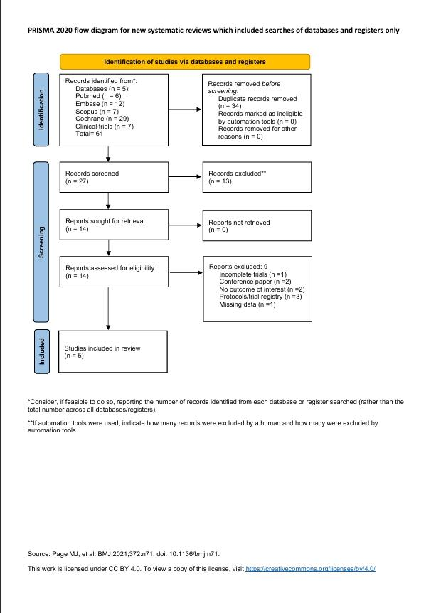

Figure 2: ROB.2.0 Traffic light plot of risk of bias across included studies
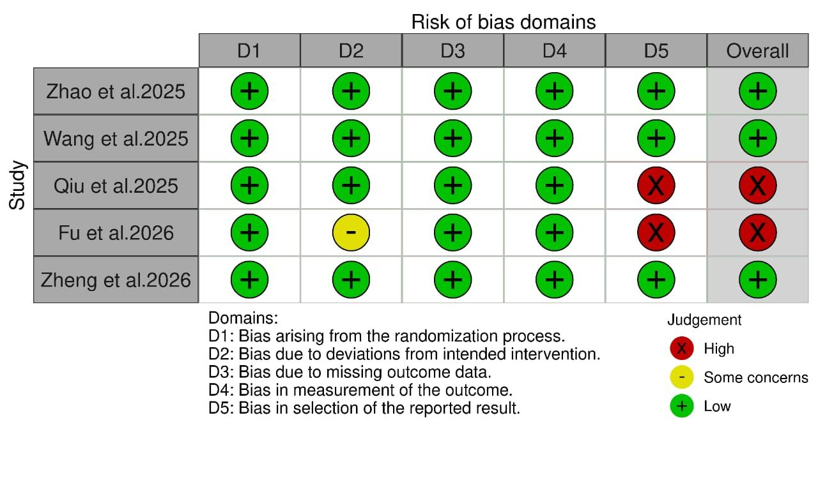

Figure 3: Forest plot of resting Summed Pain Intensity Difference over 24 hours (rSPID24)
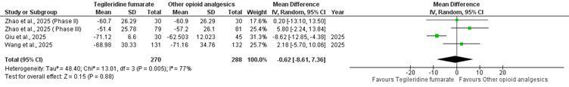

Figure 4: Forest plot of patients requiring rescue analgesia in the first 24hrs
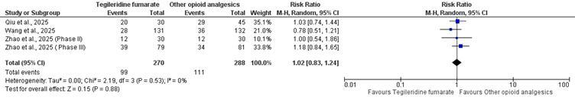

Figure 5: Forest plot of vomiting:
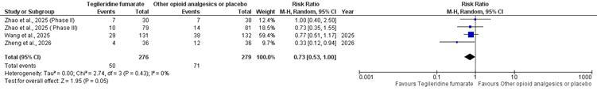

Figure 6: Forest plot of nausea
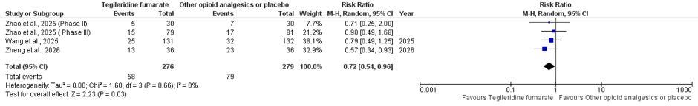

Figure 7: Forest plot of respiratory distress/ desaturation
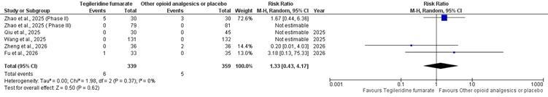

Figure 8: Forest plot of dizziness
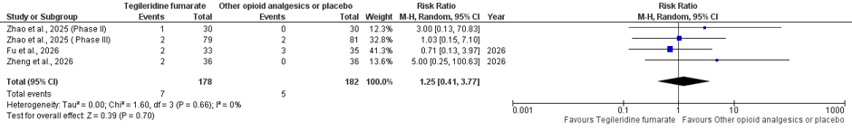

Figure 9: Forest plot of serious adverse ev

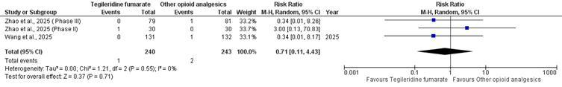

Figure 10: Central Illustration: Visual summary of the systematic review and meta-analysis.
