Levosimendan in adults with cardiogenic shock supported by VA-ECMO: updated systematic review and meta-analysis

Authors: David Woode¹, Khansa Faysal Faridi², Adan Farrukh³, Qadr Amir⁴, Mariam Mukhtar³, Muhammad Awais⁵, M. Wajahat Irshad⁶, Romesa Saqib⁷, Farouk Hijazi⁸, Maryam Sikandar², Sumia Fatima, MBBS^{3*}

Affiliations:
¹ Xavier School of Medicine, Oranjestad, Aruba
² Karachi Metropolitan University, Karachi, Pakistan
³ Rawalpindi Medical University, Rawalpindi, Pakistan
⁴ Fatima Jinnah Medical University, Lahore, Pakistan
⁵ Poonch Medical College, Rawalakot, Pakistan
⁶ Faisalabad Medical University, Faisalabad, Pakistan
⁷ Lahore Medical and Dental College, Lahore, Pakistan
⁸ Ajman University, Ajman, United Arab Emirates

Corresponding author: Sumia Fatima, MBBS
Rawalpindi Medical University, Rawalpindi, Pakistan
Email: sumiahfatima3@gmail.com
ORCID: 0000-0002-5450-4787

Author ORCIDs
David Woode: 0009-0002-3592-1865
Khansa Faysal Faridi: 0009-0000-0383-7963
Adan Farrukh: 0009-0009-1318-8958
Qadr Amir: 0009-0004-1480-6387
Mariam Mukhtar: 0009-0002-2920-5619
Muhammad Awais: 0009-0005-7980-4996
M. Wajahat Irshad: 0009-0002-2783-3064
Romesa Saqib: 0009-0001-6945-6538
Farouk Hijazi: 0009-0000-8652-9180
Maryam Sikandar: 0009-0007-0459-5506
Sumia Fatima, MBBS: 0000-0002-5450-4787

Author Emails:
David Woode: David@meditorsolutions.com
Khansa Faysal Faridi: Khansafaysalfaridi@gmail.com
Adan Farrukh: Adanfarrukh2@gmail.com
Qadr Amir: Qadr.amir@gmail.com
Mariam Mukhtar: Mariammukhtar520@gmail.com
Muhammad Awais: Godfreyofballion1187@gmail.com
M. Wajahat Irshad: Sukherawajahat@gmail.com
Romesa Saqib: Theromesasaqib@gmail.com
Farouk Hijazi: Faroukraed123@gmail.com
Maryam Sikandar: Maryamsikandar580@gmail.com
Sumia Fatima: Sumiahfatima3@gmail.com

Funding: None.
Conflicts of interest: The authors declare no conflicts of interest.
PROSPERO registration: CRD420261467713
Keywords: Levosimendan; extracorporeal membrane oxygenation; VA-ECMO; cardiogenic shock; weaning; mechanical circulatory support; inotropic agents; systematic review; meta-analysis.

Author contributions. Conception and design of the review and development of the search strategy: D.W. Study screening and selection: D.W., K.F.F., Q.A., M.W.I., M.A., R.S. Final decisions on study inclusion: D.W. Data extraction and second review: D.W., R.S., Q.A., K.F.F., A.F., M.W.I., M.A. Verification of baseline data: R.S. Statistical analysis and production of forest plots: K.F.F. (primary outcomes), A.F. (primary outcome and subgroup analysis), Q.A. and M.A. (secondary outcomes), M.M. and M.W.I. (secondary outcomes). Risk-of-bias and quality assessment: A.F., M.M. GRADE assessment: K.F.F., Q.A., D.W. Drafting of the manuscript: M.A. (introduction and abstract), R.S. (results and conclusion), Q.A. and A.F. (discussion), K.F.F. (methods). PRISMA diagram: Q.A. PROSPERO registration and duplicate resolution: K.F.F. Project coordination: D.W., F.H. Critical revision and overall editing of the manuscript: D.W. All authors approved the final version and agree to be accountable for all aspects of the work.

Abstract

Background: Patients with cardiogenic shock who are supported on veno-arterial extracorporeal membrane oxygenation (VA-ECMO) face high mortality, and successful weaning from support is a key determinant of outcome in these patients. Levosimendan is a calcium-sensitizing inotrope with cardioprotective and vasodilatory effects. It has been used widely as an adjunct to promote myocardial recovery and facilitate ECMO weaning. However, the evidence supporting its benefits has become inconsistent as two randomized controlled trials have emerged, LEVOECMO and the WEANILEVO Randomized Double-blind Multicenter Trial.
Objective: We aimed to determine whether levosimendan, compared with control, improves all-cause mortality and successful ECMO weaning in adults with cardiogenic shock on VA-ECMO, and to characterize its effects on other clinical outcomes.
Methods: We searched PubMed, Scopus, and ClinicalTrials.gov from July 12, 2026 to August 2, 2026 for studies comparing levosimendan with control in adults on VA-ECMO. This review followed PRISMA 2020 reporting standards and was registered with PROSPERO (CRD420261467713). Two reviewers independently screened studies, extracted data, and assessed risk of bias using the Cochrane RoB 2 tool for randomized controlled trials and the Newcastle-Ottawa Scale for observational studies. Risk ratios and mean differences were pooled using random-effects models.
Results: Fourteen studies met the inclusion criteria, of which 2 were randomized controlled trials and 12 were observational studies. All-cause mortality was lower with levosimendan (RR 0.86, 95% CI 0.74–0.99; P = 0.03; I² = 3%; 11 studies), and successful ECMO weaning was more common (RR 1.30, 95% CI 1.14–1.48; P = 0.0001; I² = 59%; 12 studies). In the overall analysis, duration of mechanical circulatory support was longer with levosimendan, though this did not reach significance (MD +1.88 days, 95% CI −0.05 to 3.81; P = 0.06), with the effect confined to the observational studies (MD +2.66 days) and absent in the randomized trial. Intensive care unit stay showed a similar non-significant trend toward longer stay (MD +3.94 days, 95% CI −0.09 to 7.97; P = 0.06), and hospital length of stay did not differ significantly overall.
Conclusion: In adults with cardiogenic shock supported by VA-ECMO, levosimendan was associated with lower early mortality and more frequent successful weaning, although these benefits were largely confined to observational data and were not evident in the randomized trials. The pooled analysis also showed a non-significant trend toward longer duration of mechanical support and ICU stay, with no difference in hospital length of stay. Because the evidence remains predominantly observational and heterogeneity across outcomes ranges from low to substantial, these findings should be regarded as hypothesis-generating until confirmed by adequately powered randomized trials.

Introduction

Cardiogenic shock denotes a state of profound myocardial pump failure culminating in critical hypoperfusion of the end organs and remains among the most lethal presentations encountered in contemporary cardiac care. Despite advances in early revascularization, pharmacologic support, and mechanical circulatory assistance, in-hospital mortality has persisted between 30% and 40% [1]. Its etiology is heterogeneous, encompassing acute myocardial infarction, post-cardiotomy failure, fulminant myocarditis, and decompensated chronic heart failure.
Veno-arterial extracorporeal membrane oxygenation has emerged as a widely adopted rescue method for refractory cardiogenic shock, providing temporary biventricular circulatory and respiratory support while the myocardium is undergoing recovery or while the patient is bridged to transplantation or a durable ventricular assistance device. This support, however, is not without consequences. Prolonged runs are associated complications such as hemorrhages, thromboembolism, nosocomial infections and left ventricular distension. These risks accumulate with the duration of support. Timely successful weaning is among the strongest determinants of patient outcome, yet no pharmacologic weaning strategy has achieved consensus, and conventional catecholaminergic inotropes such as dobutamine carry their own liabilities with respect to myocardial oxygen demand and the potential to provoke arrhythmias.
Levosimendan differs from these agents. As a calcium sensitizer, it enhances myocardial contractility by stabilizing the calcium-bound conformation of cardiac troponin C, thereby promoting actin-myosin cross-bridge formation without a proportionate rise in intracellular calcium or myocardial oxygen consumption [2]. It further opens ATP-sensitive potassium channels in vascular smooth muscle producing coronary, pulmonary, and systemic vasodilation, alongside some anti-inflammatory and cardioprotective effects mediated via mitochondrial K-ATP channel activation. Its active metabolite, OR-1896, sustains these effects for several days beyond a single infusion. This pharmacological profile has positioned levosimendan as an attractive adjunct for facilitating myocardial recovery and VA-ECMO weaning. This rationale is supported by early observational cohorts reporting improved weaning rates and survival.
Several systematic reviews have examined this question and reported extensively favorable associations between levosimendan and successful weaning, with some also suggesting a mortality benefit. These reviews, however, were constructed almost entirely from small, single-center observational cohorts, reflecting the near-absence of randomized evidence at the time. This landscape has since shifted and two randomized controlled trials, LEVOECMO [3] and WEANILEVO [4], have now reported their findings. Both trials were designed to test, under randomized conditions, whether levosimendan facilitates successful weaning from VA-ECMO in cardiogenic shock — the central claim of the earlier observational literature.
With these 2 Randomized control trials in mind, this review was undertaken to address this claim. We carefully evaluated the effect of levosimendan, relative to control, on all-cause mortality and successful VA-ECMO weaning as primary outcomes, with duration of mechanical circulatory support and intensive care unit and hospital length of stay assessed as secondary outcomes, in adults with cardiogenic shock supported by VA-ECMO.
2. Methods
This systematic review and meta-analysis was conducted in accordance with the Cochrane Handbook for Systematic Reviews of Interventions and the Preferred Reporting Items for Systematic Reviews and Meta-Analyses (PRISMA) guidelines (Supplementary Table S1), as an update to a previously published meta-analysis on this topic. The protocol was registered with the PROSPERO International Prospective Register of Systematic Reviews (registration number CRD420261467713)
2.1 Databases and search strategy
The studies were included from searching PubMed, Scopus, and ClinicalTrials.gov without any restriction on search date, from inception to August 2026. Search terms combined (“Levosimendan” OR “Simendan”) AND (“Extracorporeal Membrane Oxygenation” OR “VA-ECMO” OR “ECMO”) AND (“Cardiogenic Shock” OR “Shock, Cardiogenic”); the detailed search strategy is provided in Supplementary Table S2. Reference lists of included studies and relevant reviews were screened manually, and forward citation searching was performed using Web of Science.
2.2 Eligibility criteria
All records were imported into Rayyan and de-duplicated. Two authors (K.F. and M.S.) independently screened titles and abstracts, and the full texts of the remaining articles were assessed against the eligibility criteria, which were defined using the PICO framework. Population: Adults (≥ 18 years) undergoing veno-arterial extracorporeal membrane oxygenation (VA-ECMO) for cardiogenic shock of any etiology. Intervention: Infusion of levosimendan before or during VA-ECMO support. Comparator: Placebo, standard care, or another (non-levosimendan) inotrope. Outcomes: The primary outcomes were all-cause mortality within 30 days and successful weaning from mechanical circulatory support; the secondary outcomes were duration of mechanical circulatory support, intensive care unit (ICU) and hospital length of stay, and arrhythmia. Only randomized controlled trials and observational studies were included. Exclusion criteria were non-comparative or single-arm studies, case reports, reviews, editorials, animal studies, populations not in cardiogenic shock, levosimendan used solely as rescue therapy in refractory, deteriorating patients after failure of conventional treatment (planned early or peri-weaning use remained eligible), and pediatric-only cohorts (< 18 years).

2.3 Data extraction
Two independent authors extracted the first author, year of publication, study design, study duration, country, sample size, patient demographics (age, sex), Cardiogenic Shock Etiology, mechanical support type & configuration, Levosimendan Regimen (dose, loading, duration), timing category, LVEF, serum lactate, and vasoactive-inotropic score. For dichotomous outcomes, the number of events and total participants were extracted; for continuous outcomes, sample size, mean, and standard deviation were extracted as reported, with medians converted to means for analysis. For observational studies, propensity-score-matched (PSM) data were extracted where available, to reduce selection bias and baseline confounding by indication.
2.4 Assessment of risk of bias
Two independent authors (Q.A. and A.F.) assessed risk of bias for included RCTs using the Cochrane Risk of Bias 2.0 (RoB 2.0) tool across five domains: (1) the randomization process, (2) deviations from intended interventions, (3) missing outcome data, (4) measurement of the outcome, and (5) selection of the reported result. Each domain was rated as low risk, some concerns, or high risk. For cohort studies, risk of bias was assessed with the Newcastle–Ottawa Scale (NOS), evaluating selection, comparability, and outcome/exposure ascertainment. Conflicts were resolved by discussion with a third author (M.M.). The overall certainty of evidence for each outcome was graded as very low, low, moderate, or high using the GRADE framework, considering risk of bias, inconsistency, indirectness, imprecision and publication bias. A Summary of Findings with the certainty rating for each outcome is provided in Supplementary Table S3.

2.5 Statistical analysis
Continuous outcomes (e.g., duration of mechanical circulatory support, ICU and hospital length of stay, hemodynamics-cardiac index, VIS, serum lactate) were pooled as mean differences (MD) with 95% CI, and dichotomous outcomes (e.g., arrhythmia, mortality, successful weaning rate) as risk ratios (RR) with 95% CI. A random-effects model (DerSimonian and Laird) was applied uniformly across all outcomes, given the anticipated clinical and methodological heterogeneity from pooling RCTs and cohort studies. Heterogeneity was assessed using the Chi² test and I² statistic, with a Chi² P-value < 0.10 indicating statistically significant heterogeneity. P < 0.05 was considered statistically significant for pooled estimates, and all tests were two-sided. Pooled results were presented as forest plots. Funnel plots were used to assess publication bias for outcomes with at least 10 studies. Analyses were performed using Review Manager (RevMan, version 5.4; The Cochrane Collaboration, Copenhagen, Denmark). Subgroup analyses were performed on the basis of study design (randomized controlled trials versus observational studies), and leave-one-out sensitivity analyses were used to evaluate the influence of individual studies on risk of bias and heterogeneity.

3. Results

3.1 Search results
The literature search retrieved 450 records. After removal of 89 duplicates, 361 records were screened by title and abstract and 17 articles were retained for full-text assessment. Fourteen studies were included, two randomised controlled trials and twelve observational cohort studies. Three records were excluded at full text: one duplicate record of an already included cohort, one trial design and rationale paper reporting no outcome data [5], and one small case series that did not meet the prespecified population and comparator criteria [6]. The screening process is summarised in the PRISMA flow diagram, and the completed PRISMA 2020 checklist is provided as supplementary material.

3.2 Characteristics of included studies
The randomised trials were published in 2025 and 2026 and the cohort studies between 2016 and 2025. Studies were conducted across Europe, Asia, and the Middle East. All studies except the two trials were retrospective, and two of the cohorts contributed propensity-score-matched subgroups to the pooled analyses [7, 8]. All studies enrolled adults receiving veno-arterial extracorporeal membrane oxygenation or extracorporeal cardiopulmonary resuscitation for refractory cardiogenic shock or refractory cardiac arrest. Levosimendan was given as a continuous infusion in every study, most commonly at 0.1 to 0.2 μg/kg/min, with the timing of initiation ranging from early post-cannulation administration to administration in the peri-weaning period. Control groups received a matched placebo infusion in the two randomised trials, standard care with conventional vasoactive and inotropic agents in most cohorts, and milrinone as an active comparator in one study [9]. Follow-up ranged from index hospitalisation to one year. Baseline characteristics of the included studies are summarised in the study-characteristics table (Figure 2)

3.3 Quality assessment of included studies
Randomised trials: Assessment with RoB 2.0 identified low risk of bias in both trials, with a low-risk judgement in each of the five domains (see the accompanying risk-of-bias summary).
Cohort studies: Quality was assessed with the Newcastle-Ottawa Scale (NOS); all twelve non-randomised studies were rated high quality (7 to 9 stars), with six scoring the maximum 9 stars, five scoring 8 and one scoring 7. Star loss occurred almost exclusively in the comparability domain, where studies adjusted for one rather than two prespecified confounders (see the accompanying quality assessment table).

3.4 Results of meta-analysis
Pooled effect estimates, the number of contributing participants and studies, and the GRADE certainty rating for every outcome are summarised in the GRADE evidence profile.

3.4.1 Primary outcomes
All-cause mortality (in-hospital or within 30 days): Eleven studies reported early all-cause mortality in 1,311 patients. Mortality was significantly lower in the levosimendan group than in control (RR 0.86, 95% CI 0.74 to 0.99; p = 0.03, I² = 3%), corresponding to a 14% relative risk reduction. Certainty of evidence was moderate (see the corresponding forest plot). In a prespecified subgroup analysis by study design, the point estimate was identical in the two randomised trials (RR 0.85, 95% CI 0.40 to 1.79; p = 0.67, I² = 61%) and in the nine observational studies (RR 0.85, 95% CI 0.73 to 0.98; p = 0.03, I² = 0%), with no difference between subgroups (p = 1.00), although statistical significance was reached only in the observational stratum (see the corresponding subgroup forest plot).
Successful weaning from mechanical circulatory support: Twelve studies reported weaning success in 1,449 patients. Weaning was significantly more likely with levosimendan than with control (RR 1.30, 95% CI 1.14 to 1.48; p = 0.0001, I² = 59%). Both randomised trials returned exactly null estimates (Combes 2025, RR 1.00, 95% CI 0.83 to 1.21; Guinot 2026, RR 1.00, 95% CI 0.78 to 1.29), so the pooled benefit derived entirely from the observational studies. Certainty was low, with serious concerns regarding inconsistency (see the corresponding forest plot).

3.4.2 Secondary outcomes
Duration of mechanical circulatory support: Seven studies contributed analysable data. In the overall analysis, support duration was longer with levosimendan but the difference was not statistically significant (MD +1.88 days, 95% CI −0.05 to 3.81; P = 0.06), with extreme heterogeneity (I² = 88%) driven by opposing designs. Stratification by design showed the six observational cohorts were concordant and significant (MD +2.66 days, 95% CI 1.55 to 3.78; I² = 45%), whereas the single randomized trial (Combes) reported support 1.67 days shorter with levosimendan (MD −1.67 days, 95% CI −2.77 to −0.56); the test for subgroup difference was significant (χ² = 29.33, P < 0.00001). Certainty was low (see the corresponding combined and subgroup forest plots).
Intensive care unit length of stay: Six studies reported intensive care unit length of stay in 731 patients. In the overall analysis, stay was longer with levosimendan but the difference did not reach significance (MD +3.94 days, 95% CI −0.09 to 7.97; P = 0.06, I² = 82%). After exclusion of the two outlying studies (Jacky and Combes), the four remaining cohorts were concordant and significant (MD +2.63 days, 95% CI 0.66 to 4.59; I² = 0%; P = 0.009). Certainty was low (see the corresponding forest plot).
A sensitivity analysis was performed for this outcome because of the substantial heterogeneity observed when all six eligible studies were included. Combes 2025 was the only study reporting a shorter stay with levosimendan, and Jacky 2018 reported a difference markedly larger than any other study, the two most plausible sources of inconsistency. Following their exclusion, four studies and 463 patients remained and the pooled estimate was more precise and remained significant (MD +2.63 days, 95% CI 0.66 to 4.59; P = 0.009), with heterogeneity eliminated (I² = 0%), supporting the decision to perform the sensitivity analysis (see the corresponding sensitivity analysis forest plot).
Hospital length of stay: Six studies reported hospital length of stay in 735 patients. There was no significant difference between groups, although the estimate numerically favoured control (MD +4.45 days, 95% CI −2.47 to 11.36; p = 0.21, I² = 87%). Subgroup analysis by design did not resolve the heterogeneity, and the test for subgroup differences was significant (p = 0.0008), the discrepancy being driven by Combes 2025, the only study reporting a shorter hospital stay in the levosimendan arm. Certainty was very low (see the corresponding combined and subgroup forest plots).
Publication bias was not formally assessed and funnel plots were not generated, since fewer than ten studies contributed to the majority of analyses, below the threshold at which funnel plot asymmetry can be reliably interpreted.

Discussion
Levosimendan is pharmacologically distinct from the other agents used to support the failing heart. As a calcium sensitizer, it augments the responsiveness of cardiac troponin C to calcium and enhances actin–myosin cross-bridge formation, increasing contractility without the concomitant rise in intracellular calcium and myocardial oxygen demand that constrains the catecholaminergic inotropes. [10, 11] Through the opening of ATP-sensitive potassium channels it produces coronary, pulmonary, and systemic vasodilation and exerts anti-ischaemic and cardioprotective effects, [12] and its long-acting metabolite OR-1896 sustains these actions for several days after a single infusion. [13, 14] Inotropy without a proportionate oxygen cost, afterload reduction, and a sustained duration of action together provide the mechanistic rationale for the use of levosimendan to promote myocardial recovery and facilitate weaning from mechanical circulatory support.
On the basis of this rationale and a series of small observational cohorts, levosimendan has been adopted widely as an adjunct to facilitate VA-ECMO weaning, and systematic reviews published between 2019 and 2023 reported favorable associations with both weaning and survival. [15, 16, 17, 18, 19] That evidence, however, was almost entirely retrospective and single-center, and no pharmacological weaning strategy has attained consensus or guideline endorsement. The recent completion of two randomized controlled trials — LEVOECMO and WEANILEVO — has qualified these earlier conclusions, and the present review was undertaken to provide an updated estimate incorporating the randomized evidence alongside the observational literature. [3, 4]
Across the two primary and four secondary outcomes, the apparent benefits of levosimendan were concentrated in the observational evidence and were attenuated, abolished, or reversed once the analysis was stratified by study design. Of the primary outcomes, early all-cause mortality was significantly lower with levosimendan (RR 0.86, 95% CI 0.74 to 0.99; P = 0.03), with negligible heterogeneity (I² = 3%), and successful weaning from mechanical circulatory support was significantly more frequent (RR 1.30, 95% CI 1.14 to 1.48; P = 0.0001), although with substantial heterogeneity (I² = 59%). Among the secondary outcomes, the three time-related measures showed a consistent pattern in which an observational signal of longer support or stay with levosimendan was opposed by the single randomized trial. In the overall analyses, the duration of mechanical circulatory support was longer with levosimendan without reaching significance (MD +1.88 days, 95% CI −0.05 to 3.81; P = 0.06), as was the intensive care length of stay (MD +3.94 days, 95% CI −0.09 to 7.97; P = 0.06; I² = 82%), whereas the hospital length of stay did not differ significantly (MD +4.45 days, 95% CI −2.47 to 11.36; P = 0.21; I² = 87%); each was marked by extreme heterogeneity reflecting opposing designs. The single safety outcome, arrhythmia, did not differ significantly between groups (RR 1.21, 95% CI 0.74 to 1.99; P = 0.44; I² = 37%). In aggregate, therefore, levosimendan was associated with lower early mortality and improved weaning but with a non-significant trend toward longer duration of support and intensive care stay and no reduction in hospital stay; as detailed below, these benefits were largely confined to the non-randomized evidence and are best interpreted in light of the biases inherent in it.

Bias in the observational evidence
Three recurring features of the observational literature bear on every outcome discussed below and determine how much weight each estimate can support. Immortal-time bias: levosimendan was administered at the treating physician's discretion, a median of one to two days after cannulation, and no cohort adjusted for this interval. Because a patient must survive in order to be treated, the treated group is systematically advantaged before any pharmacological effect operates. As this bias act in a similar direction across cohorts, it reduces rather than increases heterogeneity, and consistency among studies that share it should not be interpreted as evidence of validity. The studies that addressed treatment timing most rigorously yielded estimates closest to the null: Massol et al. (target-trial emulation) found no effect on mortality at 30 days or one year, Paulo et al. (matching on time from ECMO initiation) found no survival or weaning benefit, and Guilherme et al. (propensity scoring, which addresses confounding by indication but not immortal-time bias) found only a non-significant trend. [20, 21, 22, 23] Definitional variability: successful weaning was defined inconsistently, ranging from survival for 24 hours after decannulation to survival of the entire admission; more permissive definitions classify patients who die shortly after decannulation as successes, which favors levosimendan because it was administered predominantly to sicker patients. [24, 25, 9] Selection by severity: levosimendan was administered preferentially to sicker patients — for example, ejection fractions of 17.9% versus 31.3% in Alonso-Fernández-Gatta and 15% versus 30% in Hau — such that comparisons partly reflect baseline severity rather than treatment effect (confounding by indication). [24, 25] This bias disadvantages levosimendan whereas immortal-time bias favors it, so within any single cohort the two are partly offsetting and their net effect cannot be determined; the two also demand different analytical remedies, since propensity methods balance baseline severity but leave the timing of treatment unaddressed.

Mortality
Early all-cause mortality favored levosimendan (RR 0.86, 95% CI 0.74 to 0.99; P = 0.03; 11 studies, 461 versus 850 patients), corresponding to a 14% relative reduction. This estimate is more conservative than those of earlier reviews — Zhao et al. reported odds ratios of 0.48 for 30-day and 0.47 for in-hospital mortality, and others reported comparable benefits [15, 16, 17, 18, 19] — for two reasons. First, those reviews expressed results as odds ratios, which overstate the effect relative to risk ratios when the baseline mortality approaches 50%. Second, the present analysis incorporates two randomized trials: Combes numerically favored placebo (RR 1.16; weight 8.1%), whereas Guinot, terminated early after enrolment of 82 of a planned 180 patients, favored levosimendan (RR 0.54) but contributed only 3.0% of the weight, with a confidence interval crossing the null. [3, 4] Heterogeneity was negligible (I² = 3%, compared with 56–70% in previous analyses); subgroup analysis confirmed that this consistency does not arise from a difference between designs, since the two estimates were identical (RR 0.85) with a null test for subgroup difference (P = 1.00) — a pattern more consistent with shared immortal-time bias.

Weaning from mechanical circulatory support
Successful weaning favored levosimendan in the overall analysis (RR 1.30, 95% CI 1.14 to 1.48), directionally consistent with Zhao et al. (OR 2.44). [15] Stratification by study design proved the most informative analysis of any outcome in this review. The two randomized trials pooled to an RR of 1.00 (95% CI 0.86 to 1.16; I² = 0%), whereas the ten non-randomized cohorts pooled to an RR of 1.40 (95% CI 1.24 to 1.57; I² = 31%), and the test for subgroup difference was highly significant (χ² = 11.80, df = 1, P = 0.0006). The confidence intervals do not overlap: the upper randomized bound of 1.16 lies below the lower observational bound of 1.24, so the two estimates are statistically incompatible. Moreover, studies of the same design were closely concordant (I² of 0% and 31%), whereas the combined analysis returned 59%; the pooled inconsistency is therefore attributable almost entirely to the difference between designs. The combined RR of 1.30 therefore represents neither body of evidence, and the stratified estimates are considered the more meaningful result. Both definitional variability and immortal-time bias operate on weaning — a patient must survive both to receive the drug and to be weaned — and neither operates within a randomized trial, which accounts for the randomized estimate lying at unity.

Duration of support and length of stay
These three outcomes largely re-measure the same underlying quantity, since the duration of support is contained within the intensive care stay and the intensive care stay within the hospital admission. Each exhibited the same pattern: an observational signal of longer support or stay with levosimendan, opposed by the single randomized trial. The duration of support was longer in the overall analysis but not significantly so (MD +1.88 days, 95% CI −0.05 to 3.81; P = 0.06), with substantial heterogeneity (I² = 88%) because the two designs pointed in opposite directions. The six observational cohorts were concordant (MD +2.66 days, 95% CI 1.55 to 3.78; I² = 45%), whereas Combes reported support 1.67 days shorter with levosimendan (test for subgroup difference χ² = 29.33, P < 0.00001). The intensive care stay was likewise longer without reaching significance (MD +3.94 days; P = 0.06; I² = 82%), driven by opposing outliers, with the four remaining observational cohorts concordant after exclusion of Jacky and Combes (+2.63 days; I² = 0%; P = 0.009). The hospital stay showed no overall difference (MD +4.45 days; P = 0.21; I² = 87%), a null result produced entirely by Combes — the only randomized trial and the only study favoring levosimendan — whose removal raised the estimate to +7.69 days. In each case, the observational direction is most plausibly explained by confounding by indication together with immortal-time bias, since sicker patients treated later in their course could not contribute short periods of support. The randomized finding, by contrast, is internally coherent, as earlier liberation from support entails earlier discharge. These findings therefore do not establish that levosimendan prolongs intensive care or hospital admission, and the three outcomes should not be regarded as independent.

Safety outcomes
Levosimendan was not associated with a significant difference in arrhythmias (RR 1.21, 95% CI 0.74 to 1.99; P = 0.44; three studies, 411 patients; I² = 37%; one contributing study reported all-cause rather than ventricular-specific arrhythmia). The estimate did, however, diverge along design lines: the two observational cohorts found no difference (RR 0.93 and 1.07), whereas Combes reported arrhythmias in 17.8% versus 8.7% of patients (RR 2.06, 95% CI 0.97 to 4.37), together with cessation of treatment for suspected adverse effects in 11.9% versus 3.8%. The most probable explanation is differential ascertainment: Combes recorded adverse events prospectively and by protocol, whereas the retrospective cohorts captured only events that were documented in the clinical record. Although its calcium-sensitizing mechanism avoids the calcium loading responsible for the arrhythmogenicity of catecholamines, a reduced propensity for arrhythmias is not equivalent to the absence of arrhythmogenicity, and the available evidence is insufficient to support a firm conclusion. Arrhythmic risk should not be disregarded, particularly in the presence of myocardial ischemia or electrolyte disturbance. [8, 9, 10]

Clinical implications and future research
Taken together, the evidence does not support the routine use of levosimendan as planned weaning therapy in cardiogenic shock. The finding that most favors the agent — improved weaning — is confined to observational data and lies at unity in the randomized trials, while the mortality signals lose significance once the timing of treatment is modelled and the randomized data remain too limited to confirm or exclude a benefit. Clinicians should therefore regard the observational weaning and survival benefits as likely overstated by immortal-time bias, definitional variability, and confounding by indication, and weigh them against the possible signals of arrhythmia and prolonged support in the single large trial to record adverse events prospectively. Adequately powered randomized trials are required; these should pre-specify the timing of administration relative to cannulation, adopt a standardized definition of successful weaning that requires survival rather than decannulation alone, and record adverse events prospectively. Where randomization is not feasible, timing-aware designs such as target-trial emulation represent the most credible alternative. [23]

Strengths and limitations
This meta-analysis incorporates both randomized and observational studies and stratifies outcomes by study design. Effects were expressed as risk ratios rather than odds ratios, avoiding the systematic overstatement that arises when event rates approach 50%. Outcomes omitted by earlier reviews, such as arrhythmia, were also reported. The randomized evidence, however, is considerably smaller than the observational evidence, and one of the two trials was terminated early. All observational studies were retrospective, with allocation determined by physician discretion, and in several cohorts levosimendan was administered to patients with poorer left ventricular function. Only two studies corrected for immortal-time bias (Paulo and Massol), and for both we extracted unadjusted event counts, which renders them more favorable in our pooled analysis than in their own; [20, 21] definitions of successful weaning varied; and the dose, loading, and timing of administration were inconsistent.
In adults with cardiogenic shock, much of it supported by VA-ECMO, levosimendan is associated with improved weaning and lower mortality in pooled analyses, but these associations depend substantially on how they are measured: the weaning benefit is confined to non-randomized evidence, and the mortality benefit attenuates when the timing of treatment is modelled. Levosimendan does not appear to increase the incidence of arrhythmia in the available data, but neither does it shorten the duration of mechanical support or reduce intensive care or hospital stay. It cannot yet be recommended as routine planned therapy in this setting, and adequately powered randomized trials — with standardized weaning definitions, pre-specified treatment timing, and prospective adverse event ascertainment are required to define its role.

5. Conclusion
In adults supported with veno-arterial extracorporeal membrane oxygenation or extracorporeal cardiopulmonary resuscitation for refractory cardiogenic shock or cardiac arrest, levosimendan reduced early all-cause mortality and increased the likelihood of successful weaning from mechanical circulatory support, without a detectable effect on hospital length of stay, and with a non-significant trend toward longer duration of mechanical support and intensive care unit stay. These findings are biologically plausible but tempered by an evidence base dominated by retrospective cohorts, in which confounding by indication and immortal-time bias are difficult to exclude. These biases may account for both the weaning signal, absent from both randomized trials, and the paradoxical prolongation of support alongside improved survival. This uncertainty is reflected in the GRADE certainty ratings, which were moderate at best and low or very low for most outcomes. The mortality signal is encouraging but hypothesis-generating; adequately powered multicentre randomised trials with standardised timing of administration and uniform weaning criteria are needed before levosimendan can be recommended in this setting.

References
- Baran DA, Grines CL, Bailey S, et al. SCAI clinical expert consensus statement on the classification of cardiogenic shock: this document was endorsed by the American College of Cardiology (ACC), the American Heart Association (AHA), the Society of Critical Care Medicine (SCCM), and the Society of Thoracic Surgeons (STS). Catheter Cardiovasc Interv. 2019;94(1):29-37. doi:10.1002/ccd.28168
- Pollesello P, Papp Z. The cardioprotective effects of levosimendan: preclinical and clinical evidence. J Cardiovasc Pharmacol. 2007;50(3):257-263. doi:10.1097/FJC.0b013e3180986230
- Combes A, Saura O, Nesseler N, et al. Levosimendan to facilitate weaning from extracorporeal membrane oxygenation in patients with severe cardiogenic shock: the LEVOECMO randomized clinical trial. JAMA. 2026;335(1):60-69. doi:10.1001/jama.2025.19843
- Guinot PG, Berthoud V, Soudry Faure A, et al. Short- and long-term efficacy and safety of levosimendan in VA-ECMO weaning: the WEANILEVO randomized double-blind multicentre trial. Anesthesiology. Published online 2026. doi:10.1097/ALN.0000000000006143
- Ellouze O, Abbad X, Constandache T, Missaoui A, Berthoud V, Puyraveau T, et al. Levosimendan in venoarterial ECMO weaning: rationale and design of a randomized double-blind multicentre trial. ESC Heart Fail. 2021;8(4):3339-3347. doi:10.1002/ehf2.13427
- Affronti A, di Bella I, Carino D, Ragni T. Levosimendan may improve weaning outcomes in venoarterial ECMO patients. ASAIO J. 2013;59(6):554-557. doi:10.1097/MAT.0b013e3182a4b32e
- Gaisendrees C, Schlachtenberger G, Gerfer S, et al. The impact of levosimendan on survival and weaning from ECMO after extracorporeal cardiopulmonary resuscitation. Artif Organs. 2023;47(10):1351-1360. doi:10.1111/aor.14567
- Vally S, Ferdynus C, Persichini R, et al. Impact of levosimendan on weaning from peripheral venoarterial extracorporeal membrane oxygenation in intensive care unit. Ann Intensive Care. 2019;9(1):24. doi:10.1186/s13613-019-0501-2
- Jacky A, Rudiger A, Krüger B, et al. Comparison of levosimendan and milrinone for ECLS weaning in patients after cardiac surgery: a retrospective before-and-after study. J Cardiothorac Vasc Anesth. 2018;32(5):2112-2119. doi:10.1053/j.jvca.2018.03.012
- Papp Z, Édes I, Fruhwald S, et al. Levosimendan: molecular mechanisms and clinical implications: consensus of experts on the mechanisms of action of levosimendan. Int J Cardiol. 2012;159(2):82-87. doi:10.1016/j.ijcard.2011.10.096
- Hasenfuss G, Pieske B, Castell M, Kretschmann B, Maier LS, Just H. Influence of the novel inotropic agent levosimendan on isometric tension and calcium cycling in failing human myocardium. Circulation. 1998;98(20):2141-2147. doi:10.1161/01.CIR.98.20.2141
- Yokoshiki H, Katsube Y, Sunagawa M, Sperelakis N. Levosimendan, a novel Ca2+ sensitizer, activates the glibenclamide-sensitive K+ channel in rat arterial myocytes. Eur J Pharmacol. 1997;333(2-3):249-259. doi:10.1016/S0014-2999(97)01098-6
- Kivikko M, Lehtonen L, Colucci WS. Sustained hemodynamic effects of intravenous levosimendan. Circulation. 2003;107(1):81-86. doi:10.1161/01.CIR.0000042672.67734.2C
- Antila S, Kivikko M, Lehtonen L, et al. Pharmacokinetics of levosimendan and its circulating metabolites in patients with heart failure after an extended continuous infusion of levosimendan. Br J Clin Pharmacol. 2004;57(4):412-415. doi:10.1046/j.1365-2125.2003.02045.x
- Zhao G, Zhao G, Zhang H, Chen W, Zhou JX, Li HL. Clinical outcomes of levosimendan administration in veno-arterial extracorporeal membrane oxygenation: a meta-analysis. BMJ Open. 2025;15:e101995. doi:10.1136/bmjopen-2025-101995
- Kaddoura R, Omar AS, Ibrahim MIM, et al. The effectiveness of levosimendan on veno-arterial extracorporeal membrane oxygenation management and outcome: a systematic review and meta-analysis. J Cardiothorac Vasc Anesth. 2021;35(9):2483-2495. doi:10.1053/j.jvca.2021.03.042
- Yang B, Zhao T, Guo B, et al. Short-term effects of levosimendan use for venoarterial extracorporeal membrane oxygenation: a systematic review and meta-analysis. Perfusion. 2023;38(2):305-312. doi:10.1177/02676591221112345
- Burgos LM, Seoane L, Furmento JF, et al. Effects of levosimendan on weaning and survival in adult cardiogenic shock patients with veno-arterial extracorporeal membrane oxygenation: systematic review and meta-analysis. Perfusion. 2020;35(6):484-491. doi:10.1177/0267659120912345
- Liu Y, Zhang L, Yao Y, et al. Effects of levosimendan on the outcome of veno-arterial extracorporeal membrane oxygenation: a systematic review and meta-analysis. Clin Res Cardiol. 2024;113(4):509-521. doi:10.1007/s00392-023-02345-6
- Massol J, Simon-Tillaux N, Tohme J, et al. Levosimendan in patients undergoing extracorporeal membrane oxygenation after cardiac surgery: an emulated target trial using observational data. Crit Care. 2023;27(1):51. doi:10.1186/s13054-023-04321-9
- Paulo N, Kimmoun A, Hajage D, et al. Does levosimendan hasten veno-arterial ECMO weaning? A propensity score matching analysis. Ann Intensive Care. 2025;15(1):48. doi:10.1186/s13613-025-01234-5
- Guilherme E, Jacquet-Lagrèze M, Pozzi M, et al. Can levosimendan reduce ECMO weaning failure in cardiogenic shock? A cohort study with propensity score analysis. Crit Care. 2020;24(1):442. doi:10.1186/s13054-020-03012-8
- Hernán MA, Robins JM. Using big data to emulate a target trial when a randomized trial is not available. Am J Epidemiol. 2016;183(8):758-763. doi:10.1093/aje/kwv341
- Alonso-Fernandez-Gatta M, Merchan-Gomez S, Gonzalez-Cebrian M, et al. Levosimendan in veno-arterial extracorporeal membrane oxygenator supported patients: impact on the success of weaning and survival. Artif Organs. 2021;45(8):717-725. doi:10.1111/aor.13890
- Hau M, Fong KM, Au SY. Levosimendan’s effect on venoarterial extracorporeal membrane oxygenation weaning. Int J Artif Organs. 2022;45(7):571-579. doi:10.1177/03913988221098765
- Chen YW, Lee WC, Wu PJ, et al. Early levosimendan administration improved weaning success rate in extracorporeal membrane oxygenation in patients with cardiogenic shock. Front Cardiovasc Med. 2022;9:912321. doi:10.3389/fcvm.2022.912321
- Kaddoura R, Orabi B, Omar AS, et al. The role of levosimendan in extracorporeal membrane oxygenation for refractory cardiac arrest. J Cardiothorac Vasc Anesth. 2025;39(6):957-966. doi:10.1053/j.jvca.2024.12.015
- Distelmaier K, Roth C, Schrutka L, et al. Beneficial effects of levosimendan on survival in patients undergoing extracorporeal membrane oxygenation after cardiovascular surgery. Br J Anaesth. 2016;117(1):52-58. doi:10.1093/bja/aew123
- Chen DL, Lin YK, Wang GJ, Chang KC. Effect of levosimendan use on all-cause mortality in out-of-hospital cardiac arrest survivors after extracorporeal cardiopulmonary resuscitation. Biomedicines. 2025;13(4):955. doi:10.3390/biomedicines13040955

Figure Legend

Figure #1. PRISMA 2020 flow diagram of study identification, screening, and inclusion.
Figure #2. Baseline characteristics of included studies
Figure #3a. Primary Outcome 1- All cause mortality
Figure #3b. Primary Outcome 1 - All-cause mortality, subgroup analysis by study design
Figure #4a. Primary Outcome 2 – Successful weaning from mechanical circulatory support.
Figure #4b. Primary Outcome 2 – Successful weaning, subgroup analysis by study design.
Figure #5. Secondary Outcome 1 – Duration of mechanical circulatory support, subgroup analysis by study design.
Figure #6a. Secondary Outcome 2 – Intensive care unit length of stay.
Figure #6b. Secondary Outcome 2 – Intensive care unit length of stay, sensitivity analysis.
Figure #7a. Secondary Outcome 3 – Hospital length of stay.
Figure #7b. Secondary Outcome 3 – Hospital length of stay, sensitivity analysis.
Figure #7c. Secondary Outcome 3 – Hospital length of stay, subgroup analysis by study design.
Figure #8. Secondary Outcome 4 – Arrhythmias.

Figure 1. PRISMA 2020 Flow diagram of study identification, screening, and inclusion

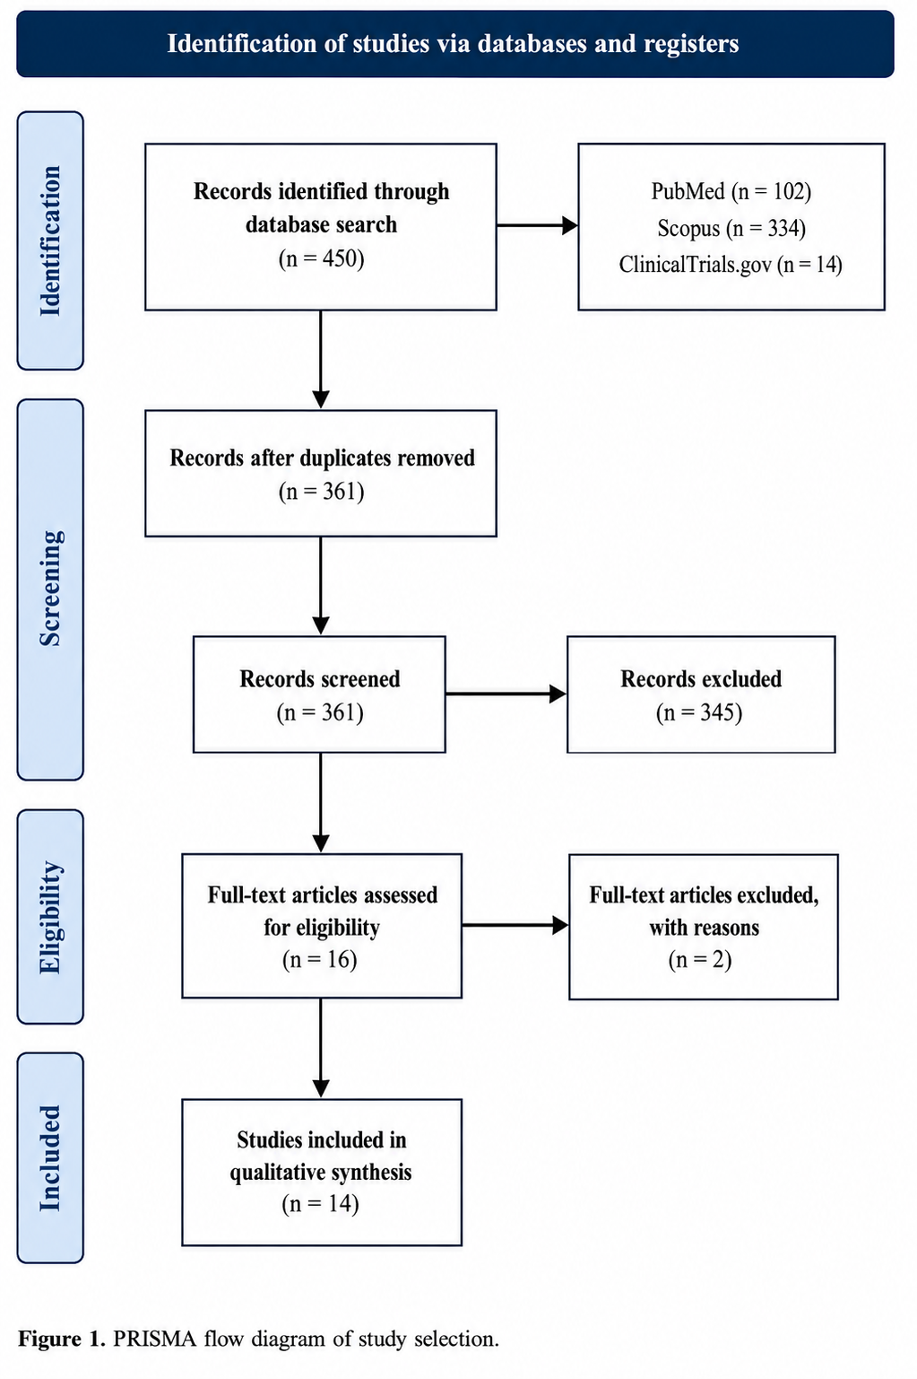

Figure 2. Characteristics of the Included Studies

Study (year) | Country | Design | N (L/C) | Age (L / C) | Male % (L/C) | LVEF % (L/C) | Levosimendan regimen | Timing | Shock etiology
Alonso-Fernandez-Gatta 2020 | Spain | Retrospective cohort | 23 / 100 | 60.3±8 / 61.9±10 | 73.9 / 73.0 | 17.9±8 / 31.3±18 | Per local protocol, 24h infusion | Peri-weaning | Mixed CS; persistent LV dysfunction
Chen 2025 | Taiwan | Retrospective cohort | 23 / 135 | 54.1±12.9 / 54.3±14.1 | 91.3 / 86.7 | 31.2±12.2 / 31.0±15.4 | 0.1 µg/kg/min ×24h | Early (<72h of ECPR) | ECPR / cardiac arrest
Chen YW 2022 | Taiwan | Retrospective cohort | 46 / 113 | 58±16.5 / 59±11.4 | 80.4 / 67.3 | 30.1±12.2 / 35.2±17.2 | 0.05–0.2 µg/kg/min ×24h | Early (<24h; median 8h) | MI, cardiac arrest
Combes 2025 (LEVOECMO) | France (11 centres) | RCT | 101 / 104 | 59±13.5 / 57.7±14.3 | 74.3 / 71.2 | 16.7±11.3 / 16.7±11.3 | 0.2 µg/kg/min ×24h, no bolus | Early (<48h) | Postcardiotomy, AMI, myocarditis
Distelmaier 2016 | Austria | Retrospective cohort | 179 / 61 | 65 (56–72) / 65 (52–70) | 74 / 63 | NR (categorical only) | 12.5 mg over 24h, no bolus | Early (<24h post-ECMO) | Post-cardiac surgery (weaning failure)
Gaisendrees 2023 | Germany | Retrospective cohort + PSM | 23 / 80 | 54.3±13.0 / 55.4±12.9 | 91.3 / 80.0 | NR | 0.2 µg/kg/min ×24h, no bolus | ICU stay, post-cannulation | eCPR / cardiac arrest
Guilherme 2020 | France | Retrospective cohort + PSM | 53 / 147 | 53.9±14.3 / 52.6±13.3 | 62.3 / 65.3 | 18 / 17 | 0.1–0.2 µg/kg/min ×24h | Peri-weaning (mean 6.6d) | Post-cardiotomy, AMI, graft dysfunction
Guinot 2026 (WEANILEVO) | France (5 centres) | RCT | 40 / 40 | 60±16 / 63±11 | 65.0 / 72.5 | 33±11 / 37±12 | 0.2 µg/kg/min ×24h, no bolus | Peri-weaning | Medical & post-cardiotomy CS
Hau 2022 | Hong Kong | Retrospective cohort + PSM | 38 / 81 | 58.4±12.5 / 54.6±14.1 | 78.9 / 71.6 | 15 / 30 (median) | 0.2 µg/kg/min, no bolus | Early (mean 1.5d) | Post-cardiotomy, ECPR, AMI
Jacky 2018 | Switzerland | Retrospective before-after | 26 / 38 | 66 (59–71) / 63 (57–71) | 80.8 / 76.3 | ≥30 (weaning criterion) | vs milrinone comparator | Peri-weaning | Post-cardiac surgery
Kaddoura 2025 | Qatar | Retrospective cohort | 18 / 69 | 41.5±23.0 / 47.0±18.0 | 88.9 / 85.5 | 15.2±21.5 | 0.1→0.2 µg/kg/min ×24h | Once stabilizing | ECPR (refractory arrest); AMI 59.8%
Massol 2023 | France | Retrospective cohort (target-trial) | 65 / 174 | 62 / 62 (median) | 66 / 61 | NR | 0.2 µg/kg/min ×24h | Early (after 24h VA-ECMO) | Post-cardiotomy CS
Paulo 2025* | France (2 centres) | Retrospective cohort | 47 / 47* | 57 (50–63) / 52 (43–60) | 74 / 71 | 15 (10–20) / 10 (5–15) | Continuous ×24h, no bolus | Stabilised, recovery potential | Mixed (AMI 74%, myocarditis 10%)
Vally 2019 | France (Réunion) | Retrospective cohort + PSM | 51 / 99 | 53.6±15.4 / 53.2±14.9 | 70.6 / 62.6 | 19.1±6.8 / 20.3±6.6 | Continuous infusion | Median 3.2d after cannulation | Mixed CS (surgical & medical)

L, levosimendan; C, control; CS, cardiogenic shock; AMI, acute myocardial infarction; ECPR, extracorporeal cardiopulmonary resuscitation; PSM, propensity-score matching; LVEF, left ventricular ejection fraction; NR, not reported. All studies used veno-arterial ECMO. Values are mean ± SD or median (IQR) as reported. For propensity-score-matched studies, full enrolled cohorts are shown; matched-subgroup data were used where specified in the pooled analyses. *Paulo 2025 N shown as pooled (47/47), pending verification. Distelmaier 2016 was included in the review but reported no outcome data in a poolable format and therefore contributes to no meta-analysis; 13 of the 14 included studies appear in the forest plo

Figure 3a. Primary Outcome 1- All Cause Mortality

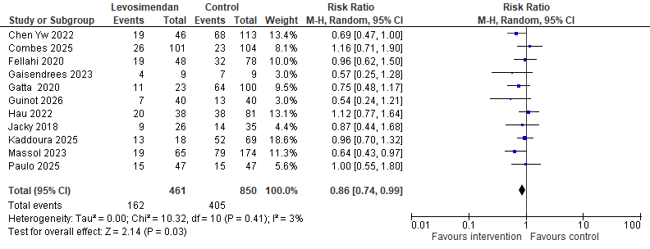
Forest plot of early all-cause mortality (in-hospital or within 30 days) comparing levosimendan with control across eleven studies. Levosimendan was associated with lower mortality (risk ratio 0.86, 95% CI 0.74 to 0.99; P = 0.03), with minimal heterogeneity (I² = 3%).

Figure 3b. Primary Outcome 1 - All-Cause Mortality, Subgroup Analysis by Study Design
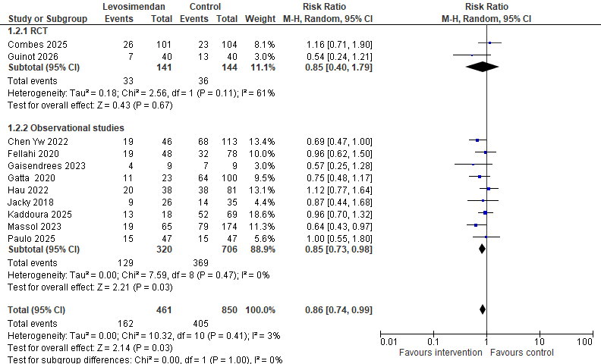
Forest plot of early all-cause mortality stratified by study design. The point estimate was similar in the two randomised trials (RR 0.85, 95% CI 0.40 to 1.79; I² = 61%) and the nine observational studies (RR 0.85, 95% CI 0.73 to 0.98; I² = 0%), with no significant difference between subgroups (P = 1.00); statistical significance was reached only in the observational stratum.

Figure 4a. Primary Outcome 2 - Successful Weaning from Mechanical Circulatory Support
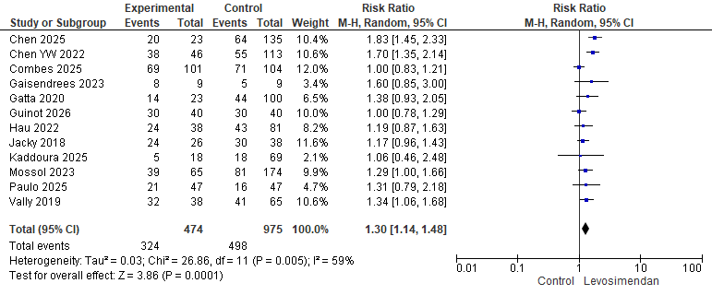
Forest plot of successful weaning from mechanical circulatory support across twelve studies. Weaning was more likely with levosimendan (RR 1.30, 95% CI 1.14 to 1.48; P = 0.0001), with moderate heterogeneity (I² = 59%).

Figure 4b. Primary Outcome 2- Successful Weaning from Mechanical Circulatory Support Subgroup Analysis by Study Design

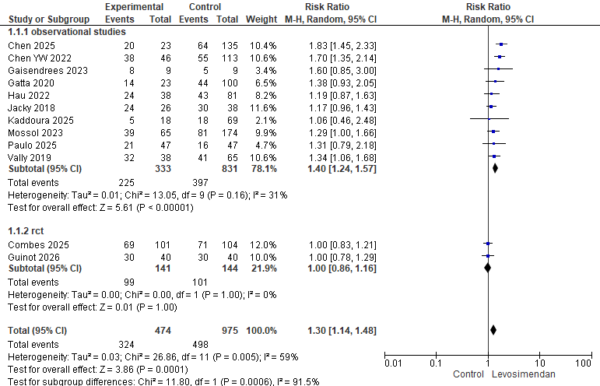
Forest plot of successful weaning stratified by study design. The benefit was confined to the ten observational studies (RR 1.40, 95% CI 1.24 to 1.57; I² = 31%), whereas the two randomised trials showed no effect (RR 1.00, 95% CI 0.86 to 1.16; I² = 0%); the test for subgroup difference was significant (χ² = 11.80, df = 1, P = 0.0006).

Figure 5. Secondary Outcome 1 - Duration of Mechanical Circulatory Support Subgroup Analysis by Study Design
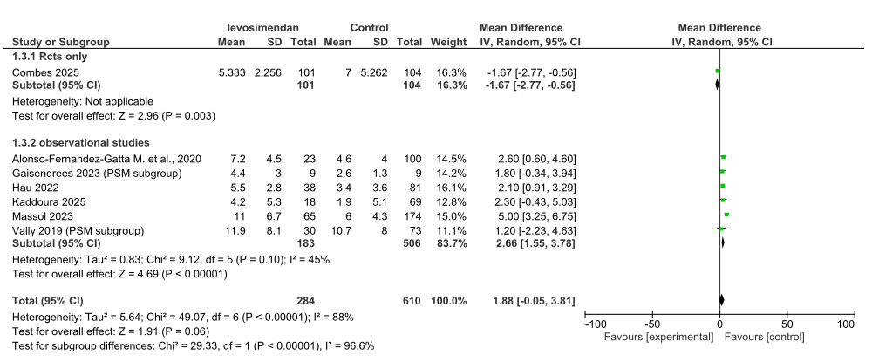

Forest plot of the duration of mechanical circulatory support (days), stratified by study design. Overall, support duration was longer with levosimendan but the difference was not statistically significant (mean difference +1.88 days, 95% CI −0.05 to 3.81; P = 0.06), with extreme heterogeneity (I² = 88%). The six observational cohorts were concordant and significant (MD +2.66 days, 95% CI 1.55 to 3.78; I² = 45%), whereas the single randomised trial reported shorter support with levosimendan (MD −1.67 days, 95% CI −2.77 to −0.56); the subgroup difference was significant (χ² = 29.33, P < 0.00001).

Figure 6a. Secondary Outcome #2 - ICU Length of Stay
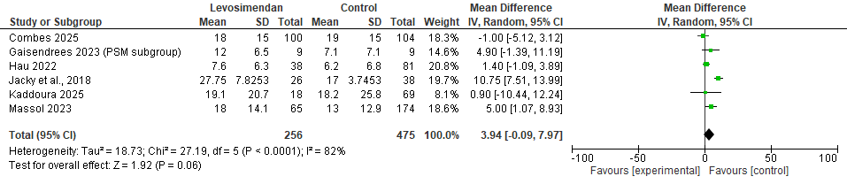
Forest plot of intensive care unit length of stay (days) across six studies. In the overall analysis, stay was longer with levosimendan but the difference did not reach significance (MD +3.94 days, 95% CI −0.09 to 7.97; P = 0.06), with substantial heterogeneity (I² = 82%).

Figure 6b. Secondary Outcome #2 - ICU Length of Stay with Sensitivity Analysis
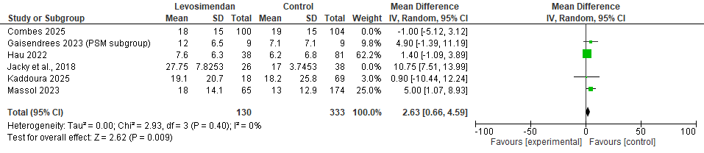

Sensitivity analysis for intensive care unit length of stay after exclusion of the two outlying studies (Jacky 2018 and Combes 2025). The four remaining cohorts were concordant and significant (MD +2.63 days, 95% CI 0.66 to 4.59; P = 0.009), with heterogeneity eliminated (I² = 0%).

Figure 7a. Secondary Outcome #3 – Hospital Length of Stay

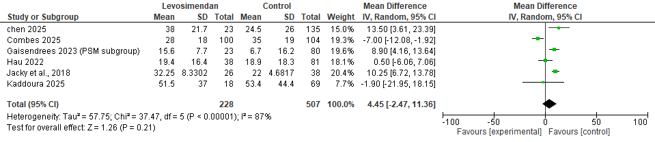
Forest plot of hospital length of stay (days) across six studies. There was no significant difference between groups, although the estimate numerically favoured control (MD +4.45 days, 95% CI −2.47 to 11.36; P = 0.21), with substantial heterogeneity (I² = 87%).

Figure 7b. Secondary Outcome #3 – Hospital Length of Stay with Sensitivity Analysis

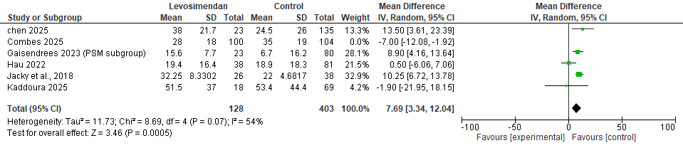
Sensitivity analysis for hospital length of stay after exclusion of the single randomised trial (Combes 2025). Among the remaining studies the estimate increased and became significant (MD +7.69 days, 95% CI 3.34 to 12.04; P = 0.0005).

Figure 7c. Secondary Outcome #3 – Hospital Length of Stay with Subgroup Analysis

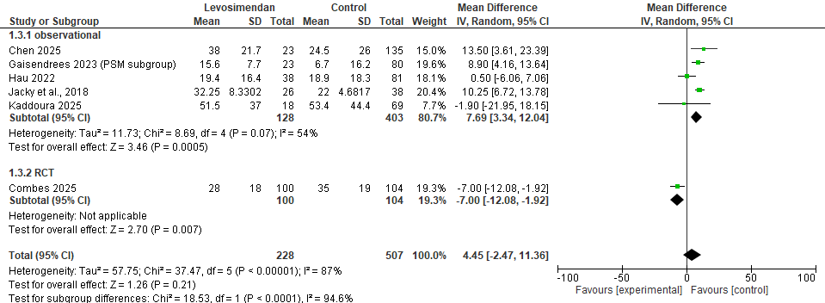

Forest plot of hospital length of stay stratified by study design. The observational studies indicated longer stay with levosimendan (MD +7.69 days, 95% CI 3.34 to 12.04), whereas the single randomised trial reported shorter stay (MD −7.00 days, 95% CI −12.08 to −1.92); the subgroup difference was significant (P < 0.0001).

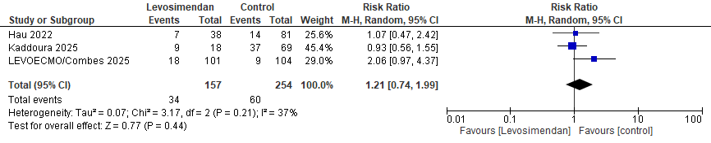
Figure 8. Secondary Outcome #4 – Arrhythmias

Forest plot of arrhythmias (n/N) across three studies. There was no significant difference between groups (RR 1.21, 95% CI 0.74 to 1.99; P = 0.44), with low-to-moderate heterogeneity (I² = 37%). One contributing study reported all-cause rather than ventricular-specific arrhythmia.

