Prophylactic Anticoagulation Added to Dual Antiplatelet Therapy for Prevention of Left Ventricular Thrombus After Anterior STEMI: Updated Systematic Review and Meta-Analysis of Randomized and Observational Studies with GRADE Assessment
David Woode¹, Zainab Batool², Zeeshan Ahmad³, Sarah Qidwai⁴, Umm e Haani², Abubakar Afzal⁵, Asra Naeem⁶, Areeba Khan⁶, Zain Ali⁷, Laiqa Iqbal⁶, Abdul Haseeb², Zaib Un Nisa⁸, Aliya Noor⁶, Abdul Majid⁹, Sumia Fatima^{7,*}
¹ Xavier School of Medicine, Oranjestad, Aruba
² University of Health Sciences, Lahore, Pakistan
³ Khyber Medical University, Peshawar, Khyber Pakhtunkhwa, Pakistan
⁴ Era's Lucknow Medical College and Hospital, Lucknow, India
⁵ Bannu Medical College, Bannu, Pakistan
⁶ King Edward Medical University, Lahore, Punjab, Pakistan
⁷ Rawalpindi Medical University, Rawalpindi, Pakistan
⁸ Northwest School of Medicine, Peshawar, Pakistan
⁹ Gajju Khan Medical College, Swabi, Khyber Pakhtunkhwa, Pakistan
* Corresponding author
Author Details (email and ORCID iD)
- David Woode — David@meditorsolutions.com | ORCID: 0009-0002-3592-1865
- Zainab Batool — zainabbatool1060@gmail.com | ORCID: 0009-0000-2272-4745
- Zeeshan Ahmad — zeeshanahmad20022002@gmail.com | ORCID: 0009-0000-7500-6990
- Sarah Qidwai — sarahqidwai14@gmail.com | ORCID: 0009-0002-8045-213X
- Umm e Haani — haano2005@gmail.com | ORCID: 0009-0002-7957-9344
- Abubakar Afzal — afzalabubakar123@gmail.com | ORCID: 0009-0006-9669-5442
- Asra Naeem — asranaeem134@gmail.com | ORCID: 0009-0008-5343-4140
- Areeba Khan — areebakha74@gmail.com | ORCID: 0009-0000-3813-589X
- Zain Ali — zain37569@gmail.com | ORCID: 0009-0005-0262-9026
- Laiqa Iqbal — laiqa.iqbal92@gmail.com | ORCID: 0009-0004-8851-896X
- Abdul Haseeb — haseebsandhu64@gmail.com | ORCID: 0009-0007-7898-8521
- Zaib Un Nisa — zaibunafzal@gmail.com | ORCID: 0009-0003-1542-5175
- Aliya Noor — aliyanoor7866@gmail.com | ORCID: 0009-0000-5376-2437
- Abdul Majid — abdul.majid@gkmcs.edu.pk | ORCID: 0009-0006-2088-1409
- Sumia Fatima — sumiahfatima3@gmail.com | ORCID: 0000-0002-5450-4787
Corresponding Author
Sumia Fatima, MBBS
Rawalpindi Medical University, Rawalpindi, Pakistan
Email: sumiahfatima3@gmail.com
ORCID: 0000-0002-5450-4787
Manuscript Information

Abstract word count: 443 words (structured: Background, Hypothesis, Methods, Results, Conclusions)
Main text word count: ~5,650 words (Introduction through Conclusion)
Tables: 5
Figures: 6 (including the PRISMA 2020 flow diagram)
Supplementary material: Supplementary Tables S1–S4; Supplementary Figures S1–S2
References: 15
Keywords
left ventricular thrombus; anterior STEMI; anticoagulation; dual antiplatelet therapy; triple therapy; meta-analysis
Registration
This systematic review was registered with the PROSPERO International Prospective Register of Systematic Reviews (registration number CRD420261449804).
Funding
This research received no specific grant from any funding agency in the public, commercial, or not-for-profit sectors.
Competing Interests
The authors declare that they have no competing interests.
Author Contributions
Conceptualization: D.W., A.M., A.No.; Methodology: Z.Ah., D.W.; Investigation (screening and data extraction): D.W., Z.B., Z.Ah., S.Q., A.K., A.Na., U.H., L.I., A.H.; Resources (literature search and full-text retrieval): Z.Al.; Data curation: D.W., Z.B., Z.Ah., A.K., U.H.; Formal analysis: D.W., Z.B., Z.Ah., U.H.; Validation: D.W., Z.B., S.Q., A.Na.; Visualization: Z.Ah., S.Q.; Writing – original draft: D.W., Z.B., Z.Ah., S.Q., A.K., A.Na.; Writing – review and editing: D.W., S.F.; Supervision: S.F.; Project administration: D.W., A.A., Z.N. All authors read and approved the final manuscript.
Author initials: D.W. = David Woode; Z.B. = Zainab Batool; Z.Ah. = Zeeshan Ahmad; S.Q. = Sarah Qidwai; U.H. = Umm e Haani; A.A. = Abubakar Afzal; A.Na. = Asra Naeem; A.K. = Areeba Khan; Z.Al. = Zain Ali; L.I. = Laiqa Iqbal; A.H. = Abdul Haseeb; Z.N. = Zaib Un Nisa; A.No. = Aliya Noor; A.M. = Abdul Majid; S.F. = Sumia Fatima.
Data Availability Statement
All data extracted and analysed during this review are included in this article and its supplementary files. The data extraction table and the RevMan analysis file are available from the corresponding author on reasonable request.
Acknowledgements
None.

.

Prophylactic Anticoagulation Added to Dual Antiplatelet Therapy for Prevention of Left Ventricular Thrombus After Anterior STEMI: Updated Systematic Review and Meta-Analysis of Randomized and Observational Studies with GRADE Assessment

ABSTRACT
Background
Left ventricular thrombus (LVT) is a well-recognized complication of anterior ST-elevation myocardial infarction (STEMI) and is associated with a substantial risk of systemic thromboembolism [1]. The 2013 ACCF/AHA STEMI guideline assigned prophylactic anticoagulation a Class IIb, Level of Evidence C recommendation in patients with anterior apical akinesis or dyskinesis [2]; the 2022 American Heart Association scientific statement on left ventricular thrombus subsequently concluded that few data support routine anticoagulation in the contemporary reperfusion, stenting and dual antiplatelet therapy (DAPT) era, and called for contemporary trials [3]. A 2024 meta-analysis by Sacoransky et al., based on four observational studies and one randomized trial, reported a significant reduction in LVT formation together with increased major bleeding [4]. Randomized evidence published since that review has not confirmed the LVT benefit.
Methods
PubMed/MEDLINE, Embase, the Cochrane Library and Scopus were searched from inception to June 2026 for randomized and observational studies comparing an anticoagulant added to DAPT versus DAPT alone in patients with anterior STEMI without baseline LVT treated with primary percutaneous coronary intervention. Outcomes were pooled as risk ratios (RR) with 95% confidence intervals using a DerSimonian–Laird random-effects model. Outcomes reported by at least three studies were meta-analysed; subgroup analysis by study design was performed where I² exceeded 50%. Certainty of evidence was assessed using GRADE.
Results
Nine studies (4,110 enrolled patients; three randomized trials and six cohorts) met the inclusion criteria, with up to 2,439 patients contributing to any single pooled outcome. Prophylactic anticoagulation was not associated with a significant reduction in LVT formation (RR 0.61, 95% CI 0.25–1.49; P = 0.28; I² = 55%; low certainty) or in MACE (RR 1.50, 95% CI 0.59–3.79; P = 0.39; I² = 64%; low certainty). It significantly increased any bleeding (RR 2.20, 95% CI 1.43–3.37; P = 0.0003; I² = 0%; moderate certainty) and major bleeding (RR 2.60, 95% CI 1.45–4.66; P = 0.001; I² = 0%; moderate certainty). All-cause mortality was reduced (RR 0.48, 95% CI 0.27–0.84; P = 0.01; I² = 0%), although this estimate rested substantially on a single observational study. Sensitivity analyses excluding a small pilot trial (LVT) and a single outlying cohort (MACE) did not alter the conclusions.
Conclusions
Prophylactic anticoagulation added to DAPT does not significantly reduce LVT formation after anterior STEMI and significantly increases bleeding. These findings do not support routine use and are consistent with the 2022 AHA scientific statement advising individualized rather than routine prophylaxis. Anticoagulation should be reserved for patients at clearly high thrombotic and low bleeding risk. Two ongoing randomized trials employing direct oral anticoagulants should further clarify this question.
Keywords: left ventricular thrombus; anterior STEMI; anticoagulation; dual antiplatelet therapy; triple therapy; meta-analysis

INTRODUCTION
Left ventricular thrombus (LVT) is a well-recognized complication following ST-segment elevation myocardial infarction (STEMI) and, if untreated, is associated with a significant increase in thromboembolic events. A meta-analysis of 11 studies (856 patients) found that echocardiographically demonstrated mural thrombus after anterior myocardial infarction increased the odds of embolization more than five-fold (OR 5.45, 95% CI 3.02-9.83) [1]. Reported incidence following anterior STEMI has ranged from 4% to 26%, with contemporary estimates of approximately 12% in the primary percutaneous coronary intervention (pPCI) era [4]. Anterior infarction with apical akinesis or dyskinesis and reduced left ventricular ejection fraction constitutes the highest-risk substrate, as regional wall-motion abnormality, endothelial injury and activation of coagulation together satisfy all components of Virchow's triad. Established LVT is conventionally managed with vitamin K antagonists (VKAs) or direct oral anticoagulants (DOACs). Whether anticoagulation should also be given prophylactically, before thrombus has formed, remains unresolved.
The 2013 ACCF/AHA STEMI guideline assigned prophylactic anticoagulation for patients with anterior apical akinesis or dyskinesis a Class IIb recommendation with Level of Evidence C, reflecting expert consensus and case series rather than trial evidence [2]. In 2022, the American Heart Association issued a scientific statement dedicated to left ventricular thrombus which revisited this position, concluding that few data clearly support routine anticoagulation in the current reperfusion, coronary stenting and dual antiplatelet therapy (DAPT) era, that no data support the previously recommended three-month duration, and that decisions are better made on a patient-by-patient basis [3]. That statement explicitly called for contemporary trials to determine whether any reduction in LVT formation outweighs the associated bleeding risk.
In 2024, Sacoransky et al. conducted a systematic review and meta-analysis of prophylactic anticoagulation added to DAPT in patients with anterior STEMI treated with pPCI [4]. Pooling five studies (four retrospective cohorts and one randomized trial; 1,461 patients), they reported a significant reduction in LVT formation (OR 0.28, 95% CI 0.11–0.73) alongside a significant increase in major bleeding (OR 2.85, 95% CI 1.13–7.24) and no significant difference in systemic embolism. They concluded that the available evidence was insufficient either to support or to oppose triple therapy for LVT prevention, and highlighted the need for larger, higher-quality studies.
Since that review, further evidence has become available — most importantly the APERITIF trial [5], a multicentre randomized trial of low-dose rivaroxaban that reported a neutral effect on LVT prevention with increased bleeding, and which is now the largest randomized study in this population. Incorporating this and other studies not captured previously offers greater precision, a broader assessment of safety and efficacy outcomes, and an appraisal of the balance of benefit and harm that reflects contemporary practice. We therefore performed an updated systematic review and meta-analysis to evaluate the efficacy and safety of prophylactic anticoagulation added to DAPT for the prevention of LVT following anterior STEMI.

METHODS
This systematic review and meta-analysis was conducted in accordance with the Cochrane Handbook for Systematic Reviews of Interventions and reported according to the Preferred Reporting Items for Systematic Reviews and Meta-Analyses (PRISMA) 2020 statement (Supplementary Table S1), as an update to a previously published meta-analysis on this topic [4]. The protocol was registered with the PROSPERO International Prospective Register of Systematic Reviews (CRD420261449804).

Databases and Search Strategy
PubMed/MEDLINE, Embase, the Cochrane Library and Scopus were searched from inception to June 2026. ClinicalTrials.gov was searched separately to identify ongoing or unpublished trials. Records identified there were used only to describe the ongoing trial landscape and did not contribute to any pooled analysis. The search was re-run from inception, rather than restricted to the period since the prior review (to June 2022), to ensure comprehensive capture of eligible studies given the broadened eligibility criteria of this update. Search terms combined ("Myocardial Infarction"[Mesh] OR STEMI OR "ST elevation myocardial infarction" OR "ST-segment elevation myocardial infarction" OR "acute myocardial infarction" OR "anterior myocardial infarction") AND ("Percutaneous Coronary Intervention"[Mesh] OR PCI OR PPCI OR "primary percutaneous coronary intervention") AND ("Ventricular Thrombus"[Mesh] OR "left ventricular thrombus"). The full strategy for each database is provided in Supplementary Table S2. Reference lists of included studies and relevant reviews were screened manually, and forward citation searching was performed using Web of Science.

Eligibility Criteria
All records were imported into Rayyan and de-duplicated. Titles and abstracts were screened independently and in duplicate by nine reviewers (D.W., Z.Ah., Z.B., U.H., S.Q., A.N., A.K., A.H., L.I.) working in pairs, with each record assessed by two reviewers; full texts of records retained after screening were assessed against the eligibility criteria in the same manner. Disagreements were resolved by discussion, with a third reviewer adjudicating where consensus could not be reached.
Studies were eligible according to the following PICO framework. Population: adults (≥18 years) with anterior (left anterior descending territory) acute myocardial infarction treated with primary PCI, with no LVT detected at baseline. Intervention: prophylactic anticoagulation with any agent (vitamin K antagonist, direct oral anticoagulant including low-dose rivaroxaban 2.5 mg twice daily, or heparin/low-molecular-weight heparin) added to DAPT ("triple therapy"), administered with preventive intent in patients without LVT, regardless of intensity or duration. Comparator: DAPT alone (aspirin plus a P2Y12 inhibitor) without added anticoagulant. Outcomes: the primary outcome was incident LVT formation; secondary outcomes were major bleeding, any (total) bleeding, all-cause mortality, major adverse cardiovascular events (MACE) and systemic embolism.
Both randomized controlled trials and observational cohort studies were eligible. Exclusion criteria were animal studies, case reports, phase 1 trials, reviews, editorials, conference abstracts without an accompanying peer-reviewed full-text report, and non-English articles. Studies in which anticoagulation was administered to treat established LVT, rather than to prevent it, were excluded.
This update differs from the previous meta-analysis [4] in three respects: it incorporates randomized evidence published subsequently, most notably the APERITIF trial [5]; it evaluates a broader range of clinical outcomes, including all-cause mortality and MACE, which were not previously pooled; and it analyses randomized and observational evidence as distinct strata where heterogeneity warranted.

Data Extraction
Five reviewers (D.W., Z.Ah., A.K., Z.B., U.H.) independently extracted data in duplicate using a piloted, standardized form. Extracted variables were first author, year of publication, country, study design, trial registration number, population, total sample size, intervention and control group sizes, patient demographics (age and sex), anticoagulant type, dose and duration, background DAPT regimen, comparator, LVT imaging modality, left ventricular ejection fraction, prevalence of diabetes mellitus and hypertension, follow-up duration, and primary and secondary outcome measures. For dichotomous outcomes, the number of events and the number of participants in each arm were extracted as reported. Where a study reported outcomes at more than one timepoint or under more than one analysis principle, a single estimate was selected per study per outcome according to pre-specified rules: intention-to-treat data were used in preference to per-protocol data, and the timepoint closest to that reported by the other studies contributing to the same outcome was used. Accordingly, the 30-day intention-to-treat data of Zhang et al. [6] were used for LVT formation, systemic embolism and any bleeding, and the 180-day intention-to-treat data for all-cause mortality and major bleeding. Where a study reported only proportions rather than raw event counts, counts were back-calculated from the reported percentages and denominators and verified by round-trip recalculation; studies requiring this derivation are identified in the Results and considered in the Limitations.

Assessment of Risk of Bias and Certainty of Evidence
Three reviewers (Z.B., S.Q., A.N.) independently assessed risk of bias. For randomized trials the Cochrane Risk of Bias 2.0 (RoB 2) tool was used across five domains: the randomization process; deviations from intended interventions; missing outcome data; measurement of the outcome; and selection of the reported result. Each domain and the overall judgement were rated as low risk, some concerns, or high risk. For observational cohort studies the Newcastle–Ottawa Scale (NOS) was used, assessing selection of study groups (maximum 4 stars), comparability of cohorts (maximum 2 stars) and outcome assessment (maximum 3 stars), yielding a maximum of 9 stars; scores of 7 or above were considered good quality. Disagreements were resolved by discussion with a fourth reviewer (D.W.).
Certainty of evidence for each outcome was assessed using the GRADE framework and rated as very low, low, moderate or high, considering risk of bias, inconsistency, indirectness, imprecision and publication bias. Because every outcome in this review was informed by a body of evidence that included observational studies, the starting certainty was set at moderate for all outcomes rather than applying the conventional design-based starting points of high for randomized and low for observational evidence; this convention was pre-specified and is applied uniformly. Where inconsistency and imprecision reflected a single, related limitation, certainty was downgraded once for the combined concern rather than once per domain. A Summary of Findings table is provided in Supplementary Table S3.

Statistical Analysis
All outcomes were dichotomous and were pooled as risk ratios (RR) with 95% confidence intervals (CI) by three authors (Z.A., Z.B., U.H.). A random-effects model (DerSimonian and Laird) was applied to all analyses to account for anticipated clinical and methodological heterogeneity. An outcome was meta-analysed only if reported by three or more studies; outcomes reported by fewer than three studies were summarized narratively and not pooled. Statistical heterogeneity was assessed using the Chi² test and the I² statistic, with a Chi² P value <0.05 indicating statistically significant heterogeneity, and I² values of 25%, 50% and 75% regarded as low, moderate and substantial respectively. Statistical significance for pooled effect estimates was defined as a two-sided P value <0.05. Pooled results are presented as forest plots.
Two distinct secondary analyses were pre-specified. First, subgroup analysis by study design (randomized versus observational) was performed for any outcome with substantial heterogeneity (I² >50%), with a test for subgroup differences reported; this threshold was applied uniformly, and outcomes with I² ≤50% were not subgrouped. Second, sensitivity analyses were performed by removing individual studies identified a priori as potential sources of methodological influence, in order to assess the robustness of the pooled estimate: the pilot feasibility trial of Schwalm et al. [7], which was not powered for efficacy, was excluded in a sensitivity analysis of the primary outcome, and Le May et al. [8] was excluded in a sensitivity analysis of MACE. An exploratory subgroup analysis of the primary outcome according to anticoagulant class (vitamin K antagonist, direct oral anticoagulant, or low-molecular-weight heparin) was also performed; given the small number of studies within each class this analysis was regarded as hypothesis-generating. All analyses were performed using Review Manager (RevMan, version 5.4; The Cochrane Collaboration, Copenhagen, Denmark).

RESULTS

Study Selection
The database search identified 6,097 records: 3,054 from PubMed/MEDLINE, 2,331 from Embase, 447 from the Cochrane Library and 265 from Scopus. Following removal of 418 duplicates, 5,679 unique records were screened, of which 5,665 were excluded at title and abstract stage. Fourteen full-text articles were sought and all were retrieved and assessed for eligibility. Five reports were excluded at full-text review, with reasons detailed in Supplementary Table S4. Nine studies met the inclusion criteria and were included in the review (Figure 1). No eligible study of high-risk LAD-territory NSTEMI was identified. The pre-specified sensitivity analysis for this population was therefore not required.

Study Characteristics
The nine included studies enrolled a total of 4,110 patients with anterior STEMI treated with primary PCI, comparing an anticoagulant (rivaroxaban, warfarin, a vitamin K antagonist, or enoxaparin) added to DAPT against DAPT alone. Three studies were randomized controlled trials (Puymirat et al. [APERITIF] 2026 [5]; Zhang et al. 2022 [6]; Schwalm et al. [WAAMI pilot] 2010 [7]) and six were observational cohort studies (Le May et al. 2015 [8]; Bastiany et al. 2018 [9]; Chen et al. 2020 [10]; Oyetayo et al. 2015 [11]; Shavadia et al. 2017 [12]; Boivin-Proulx et al. [MAGIC] 2022 [13]). Studies were conducted in Canada (n = 5), China (n = 2), France (n = 1) and the United States (n = 1). Follow-up ranged from 30 days to 12 months. Study characteristics are summarized in Table 1.
Two included cohorts, Bastiany et al. 2018 [9] and Boivin-Proulx et al. (MAGIC) 2022 [13], drew from overlapping source centres (CHUM and CHUS, Quebec) and overlapping enrolment periods (2013–2015 and 2009–2017 respectively), with shared senior investigators, raising the possibility of shared patients. The two studies were not co-pooled within any single synthesized outcome: Bastiany contributed to the LVT, MACE, all-cause mortality and major bleeding analyses, whereas the outcome reported by MAGIC (net adverse clinical events) was reported by fewer than three studies and was therefore not meta-analysed under our pre-specified threshold. MAGIC met the eligibility criteria and is retained as an included study and described narratively, but contributed to no pooled effect estimate; consequently this potential overlap does not affect any pooled result presented below. It does affect the aggregate enrolled patient count, and should be verified against the MAGIC methods before the two cohorts are combined in any future analysis. Of the 4,110 enrolled patients, up to 2,439 contributed to any single pooled outcome.

Risk of Bias in Included Studies
Two of the three randomized trials were judged at low overall risk of bias (Puymirat 2026 [5] and Zhang 2022 [6]), reflecting adequate randomization, minimal deviation from intended interventions, complete outcome data and objective outcome assessment. Schwalm 2010 [7] was judged at high overall risk of bias, driven by some concerns in the randomization process and in deviations from intended interventions, and high risk in measurement of the outcome, consistent with its open-label, unblinded, underpowered feasibility design and the absence of a registered protocol (Table 2). All six cohort studies were rated as good quality on the Newcastle–Ottawa Scale (range 7/9 to 9/9), reflecting adequate cohort selection, comparability and ascertainment or adequacy of follow-up (Table 3).

Synthesis of Results
Primary outcome: LV thrombus formation
Six studies comprising 1,581 participants reported incident LVT formation. Prophylactic anticoagulation was not associated with a statistically significant reduction compared with DAPT alone (RR 0.61, 95% CI 0.25–1.49; P = 0.28), with moderate heterogeneity (I² = 55%) (Figure 2). LVT occurred in 47 of 702 patients (6.7%) receiving anticoagulation versus 83 of 879 (9.4%) receiving DAPT alone, an absolute risk difference of 2.7%. Because heterogeneity exceeded the pre-specified 50% threshold, subgroup analysis by study design was performed: effect estimates were similar in the randomized (RR 0.53, 95% CI 0.10–2.96; I² = 65%) and observational (RR 0.71, 95% CI 0.15–3.49; I² = 57%) subgroups, with no significant subgroup difference (P = 0.81), indicating that heterogeneity was not explained by study design and more plausibly reflected differences in the timing of thrombus assessment (approximately 7 days to 3 months) and imaging modality (cardiac magnetic resonance versus transthoracic echocardiography). The pre-specified sensitivity analysis excluding the underpowered Schwalm 2010 pilot trial produced a consistent, non-significant result (RR 0.54, 95% CI 0.21–1.40; P = 0.21; I² = 61%) (Supplementary Figure S1).
In the exploratory subgroup analysis by anticoagulant class, studies using vitamin K antagonists [7,9,11] showed no evidence of benefit (RR 2.07, 95% CI 0.52–8.18), whereas those using direct oral anticoagulants [5,6] (RR 0.33, 95% CI 0.04–2.97) and low-molecular-weight heparin [10] (RR 0.29, 95% CI 0.10–0.84) trended toward benefit. Given the small number of studies per class and confounding with study era and imaging modality, this analysis is hypothesis-generating only.
Major adverse cardiovascular events
Three studies involving 1,192 participants reported MACE. There was no significant difference between groups (RR 1.50, 95% CI 0.59–3.79; P = 0.39), with substantial heterogeneity (I² = 64%) concentrated in the observational subgroup (I² = 79%) and driven by Le May 2015 (RR 3.35, 95% CI 1.45–7.76), the only study reporting a significantly higher MACE rate with anticoagulation (Figure 3). Subgroup analysis by design did not explain the heterogeneity (test for subgroup differences P = 0.37). The pre-specified sensitivity analysis excluding Le May 2015 produced a null pooled estimate with no residual heterogeneity (RR 1.00, 95% CI 0.56–1.79; P = 0.99; I² = 0%), indicating that the heterogeneity was attributable to this single study (Supplementary Figure S2).
All-cause mortality
Five studies involving 1,840 participants reported all-cause mortality. Anticoagulation was associated with a statistically significant reduction (RR 0.48, 95% CI 0.27–0.84; P = 0.01), with no heterogeneity (I² = 0%) (Figure 4). Death occurred in 17 of 889 patients (1.9%) receiving anticoagulation versus 38 of 951 (4.0%) receiving DAPT alone. Shavadia 2017 (RR 0.29, 95% CI 0.12–0.75) was the largest contributor to the pooled effect (36.9% weight), followed by Chen 2020 (RR 0.51, 95% CI 0.17–1.56; 26.0% weight). Because the event counts of Shavadia 2017 were derived from reported percentages rather than raw counts, this finding warrants cautious interpretation.
Any (total) bleeding
Three studies involving 963 participants reported total (any) bleeding. Anticoagulation significantly increased the risk of any bleeding (RR 2.20, 95% CI 1.43–3.37; P = 0.0003), with no heterogeneity (I² = 0%) and a consistent direction of effect across all three contributing studies (Figure 5). Any bleeding occurred in 58 of 460 patients (12.6%) receiving anticoagulation versus 28 of 503 (5.6%) receiving DAPT alone, an absolute risk increase of 7.0% (approximately one additional event per 14 patients treated). Heterogeneity did not exceed the pre-specified threshold and subgroup analysis was therefore not performed.
Major bleeding
Eight studies involving 2,439 participants reported major bleeding. Anticoagulation significantly increased the risk (RR 2.60, 95% CI 1.45–4.66; P = 0.001), with no heterogeneity (I² = 0%) (Figure 6). Major bleeding occurred in 32 of 1,069 patients (3.0%) receiving anticoagulation versus 17 of 1,370 (1.2%) receiving DAPT alone, an absolute risk increase of 1.8% (approximately one additional major bleed per 57 patients treated). This outcome was supported by the largest number of studies and showed the most consistent direction of effect across the body of evidence.
Systemic embolism
Systemic embolism was reported by three studies [5,6,11]; however, one contributed no events in either arm (Oyetayo 2015: 0/44 versus 0/80), leaving two informative studies. Under the pre-specified threshold requiring three or more contributing studies, this outcome was not meta-analysed and is reported narratively. Individual estimates were directionally consistent with a reduction (Puymirat 2026: 2/277 versus 4/283; Zhang 2022: 1/139 versus 4/140), in keeping with the non-significant reduction reported by Sacoransky et al. (OR 0.37, 95% CI 0.12–1.13) [4].
Pooled effect estimates for all meta-analysed outcomes are summarized in Table 4.

Certainty of the Evidence (GRADE)
Certainty of evidence started at moderate for all outcomes, as pre-specified, because every outcome was informed by a body of evidence including observational studies, and was downgraded for serious inconsistency and/or imprecision where present. Indirectness was not serious for any outcome. Publication bias could not be assessed, as fewer than ten studies contributed to any outcome, precluding funnel plot inspection or Egger's test. Risk of bias was not rated down for any outcome; although Schwalm 2010 was judged at high overall risk of bias, it contributed less than 7% of the weight to either of the outcomes to which it contributed (LVT formation and major bleeding), and all observational studies were rated good quality on the Newcastle–Ottawa Scale (Table 5).
In summary, across nine studies (4,110 enrolled patients, of whom up to 2,439 contributed to any single pooled outcome), prophylactic anticoagulation added to DAPT after anterior STEMI showed moderate-certainty evidence of a significant increase in both any bleeding and major bleeding, low-certainty evidence of no significant reduction in LV thrombus formation or MACE, and moderate-certainty evidence of a reduction in all-cause mortality that should be interpreted cautiously given its dependence on a single observational study.

DISCUSSION
Left ventricular thrombus formation remains an important complication following acute myocardial infarction, particularly in STEMI with reduced ejection fraction and apical or anterior akinesis or dyskinesis. Such wall-motion abnormalities, combined with impaired systolic function, promote all components of Virchow's triad and result in intracavitary thrombus. Although advances in reperfusion and antithrombotic therapy have reduced the risk of LVT, it remains associated with systemic thromboembolism, stroke and increased morbidity [1]. DAPT is the standard antithrombotic regimen following acute coronary syndrome and effectively reduces platelet-mediated thrombotic events; however, LVT formation is driven by additional mechanisms — ventricular stasis, endothelial injury and activation of coagulation pathways — that may not be fully addressed by antiplatelet therapy alone. The addition of prophylactic anticoagulation to DAPT has therefore been proposed to provide complementary inhibition of thrombus formation in patients at high risk of LVT.

Primary Outcome: Left Ventricular Thrombus Formation
The pooled effect estimate for LVT formation favoured anticoagulation but did not reach statistical significance (RR 0.61, 95% CI 0.25–1.49), with a confidence interval crossing unity and moderate heterogeneity (I² = 55%). The certainty of evidence was low. These findings indicate that the currently available evidence is insufficient to establish a definitive protective effect of prophylactic anticoagulation against LVT formation after anterior STEMI.
Our estimate is more conservative than that of Sacoransky et al. [4], who reported a significant reduction (OR 0.28, 95% CI 0.11–0.73). Although both analyses point in the same direction, ours did not reach significance and yielded a more modest effect size. The principal reason is the inclusion of the APERITIF trial [5], the largest randomized trial in this population, which was neutral (RR 0.83) and contributed the greatest weight (34.5%) to our analysis; the earlier estimate leaned substantially on Zhang et al. [6] (OR 0.08) and Chen et al. [10] (OR 0.28), both of which reported strong benefit. Differences in thrombus detection strategy, follow-up duration, anticoagulant regimen and baseline patient risk may have contributed further.
Subgroup analysis by study design demonstrated comparable treatment effects in randomized and observational studies, with no significant subgroup interaction (P = 0.81). Substantial heterogeneity persisted within both subgroups, indicating that study design did not account for the variation observed. Notably, the randomized subgroup estimate (RR 0.53) was numerically more favourable than the observational estimate (RR 0.71), which argues against the difference from the earlier review being explained by confounding by indication in observational data. The heterogeneity is more plausibly attributable to differences in the timing of thrombus assessment, ranging from approximately one week to three months, and to differences in imaging modality — transthoracic echocardiography versus cardiac magnetic resonance imaging, the latter having substantially greater sensitivity for detecting LVT (reported sensitivities of 23% and 88% respectively when validated against surgical or pathological findings) [14]. The sensitivity analysis excluding the Schwalm pilot trial [7] produced a consistent estimate (RR 0.54, 95% CI 0.21–1.40), confirming that the null result was not driven by that small study.
A further potential source of heterogeneity is anticoagulant class. In an exploratory analysis, vitamin K antagonist studies [7,9,11] showed no evidence of benefit (RR 2.07), whereas direct oral anticoagulant [5,6] (RR 0.33) and low-molecular-weight heparin [10] (RR 0.29) studies trended toward benefit. This pattern has biological plausibility: warfarin requires several days to achieve a therapeutic international normalized ratio and may therefore fail to provide adequate anticoagulation during the critical early window in which LVT typically forms, whereas direct oral anticoagulants and low-molecular-weight heparin act immediately. However, anticoagulant class is confounded with study era and imaging modality — the vitamin K antagonist studies are older and relied on echocardiography — and each subgroup contained few studies. This observation is hypothesis-generating rather than confirmatory, though it is notable that both ongoing randomized trials have selected direct oral anticoagulants.

Safety Outcomes
Anticoagulation significantly increased major bleeding (RR 2.60, 95% CI 1.45–4.66), with no heterogeneity and moderate certainty. Major bleeding occurred in 3.0% versus 1.2% of patients, an absolute increase of 1.8% and a number needed to harm of approximately 57. This is consistent with Sacoransky et al. [4] (OR 2.85, 95% CI 1.13–7.24). The absence of heterogeneity despite differences in study design, anticoagulant regimen, treatment duration and bleeding definitions supports the reliability of this estimate, and the inclusion of APERITIF [5] provides greater precision than was previously available.
Any (total) bleeding was likewise significantly increased (RR 2.20, 95% CI 1.43–3.37), with no heterogeneity and moderate certainty — 12.6% versus 5.6%, or approximately one additional bleeding event for every 14 patients treated. The effect was consistent across Oyetayo et al. [11], Puymirat et al. [5] and Zhang et al. [6], with the randomized evidence reinforcing rather than diverging from the observational data. As Sacoransky et al. [4] reported only major bleeding, this outcome adds a more inclusive layer of evidence to the safety profile of triple therapy.

All-Cause Mortality
All-cause mortality was significantly reduced (RR 0.48, 95% CI 0.27–0.84), with no heterogeneity and moderate certainty; death occurred in 1.9% versus 4.0% of patients. Shavadia et al. [12] and Chen et al. [10] carried the greatest weight (36.9% and 26.0%). Because Sacoransky et al. [4] evaluated only LVT formation, major bleeding and systemic embolism, no pooled analysis of mortality was previously available; this study therefore addresses a gap in the literature.
This finding must nonetheless be interpreted with considerable caution, as it is difficult to reconcile with the remainder of our results. We observed no significant reduction in LVT formation, no reduction in MACE, and a significant increase in bleeding — none of which provides a plausible causal pathway through which anticoagulation would reduce death. If the intervention does not prevent thrombus, stroke or major cardiovascular events, and simultaneously increases haemorrhagic complications, a halving of mortality lacks an evident mechanism. Several explanations are more likely than a genuine treatment effect. First, confounding by indication may operate in the opposite direction to that usually assumed: clinicians may preferentially withhold anticoagulation from frail patients or those with competing comorbidities and a high short-term risk of death, so that patients selected for anticoagulation are systematically healthier at baseline. Residual confounding of this kind cannot be excluded, and four of the five contributing studies were non-randomized. Second, the total number of deaths was small (55 across 1,840 patients), so the estimate is fragile. Third, the largest contributor [12] provided event counts derived from reported percentages rather than published raw numbers, introducing additional imprecision into the study carrying more than a third of the weight. This mortality signal should therefore be regarded as hypothesis-generating and requires confirmation in adequately powered randomized trials before any causal inference is drawn.

Major Adverse Cardiovascular Events
There was no significant difference in MACE (RR 1.50, 95% CI 0.59–3.79), with substantial heterogeneity (I² = 64%) that subgroup analysis by design did not explain (P = 0.37); certainty was low. The overall estimate was consistent with APERITIF [5] (RR 0.68) and Bastiany et al. [9] (RR 1.04), both reporting no significant difference. In contrast, Le May et al. [8] (RR 3.35, 95% CI 1.45–7.76) observed a significantly higher MACE rate with anticoagulation and was the principal contributor to the heterogeneity. Sensitivity analysis excluding Le May eliminated heterogeneity entirely (I² = 0%) and yielded a null effect (RR 1.00, 95% CI 0.56–1.79), indicating that the variability was driven by a single observational outlier rather than a true difference in treatment effect. The discrepant findings of Le May et al. may reflect confounding by indication, non-randomized allocation, prolonged follow-up (180 days) and preferential anticoagulation of higher-risk patients. As Sacoransky et al. [4] did not evaluate MACE, this analysis addresses a further gap.

Clinical Implications
Taken together, these findings describe an unfavourable balance between benefit and harm. The evidence for the intended benefit — prevention of LVT — is of low certainty and did not reach statistical significance, and no reduction was demonstrated in MACE or in embolic events. By contrast, the evidence for harm is consistent, of moderate certainty and free of heterogeneity: anticoagulation approximately doubled total bleeding and more than doubled major bleeding, with roughly one additional major bleed for every 57 patients treated and one additional bleed of any severity for every 14. An apparent mortality benefit was observed but lacks a plausible mechanism and is most likely explained by residual confounding.
Our findings align closely with the current direction of expert opinion. The 2013 ACCF/AHA STEMI guideline assigned prophylactic anticoagulation for anterior apical akinesis or dyskinesis a Class IIb, Level of Evidence C recommendation [2] — a designation reflecting expert consensus rather than trial evidence. The 2022 AHA scientific statement on left ventricular thrombus subsequently revisited this position, concluding that few data clearly support routine anticoagulation in the contemporary reperfusion, stenting and DAPT era, that no data support the specific three-month duration previously recommended, and that weighing risks and benefits on a patient-by-patient basis is the more prudent approach; it explicitly called for contemporary trials to resolve whether any reduction in LVT formation outweighs the associated bleeding risk [3]. Our results provide precisely that contemporary evidence and support the more restrictive position.
Notably, no current guideline has yet incorporated the most recent randomized evidence: the 2025 ACC/AHA guideline for the management of acute coronary syndromes [15] was informed by a literature search concluding in April 2024, and the 2023 ESC acute coronary syndromes guideline earlier still, both predating publication of APERITIF [5]. Our synthesis therefore provides the most current appraisal of the balance of benefit and harm available to guide practice while awaiting the results of ongoing trials.
Any decision to use prophylactic anticoagulation should be individualized rather than routine. A selective approach may remain reasonable in patients at the highest thrombotic risk — for example those with severely reduced ejection fraction, extensive apical akinesis or dyskinesis involving multiple segments, or documented left ventricular aneurysm — provided bleeding risk is low. Conversely, it should generally be avoided in patients of advanced age or with prior bleeding, anaemia, renal impairment, or concomitant medications increasing haemorrhagic risk. Where anticoagulation is used, the considerations above suggest agents achieving immediate therapeutic effect may be preferable to vitamin K antagonists, although this remains unproven.

Future Directions
Two adequately designed randomized trials are underway and should substantially clarify this question. The PREVENT trial (NCT06013020) is evaluating Century Clot-guided rivaroxaban added to DAPT in patients with anterior STEMI at risk of LVT, with LVT formation and net adverse clinical events assessed at one and twelve months. The POTAMI trial (NCT06742567) is evaluating apixaban prophylaxis in patients with anterior myocardial infarction and ejection fraction below 35%, with LVT formation assessed at four weeks. Both employ direct oral anticoagulants rather than vitamin K antagonists, consistent with the mechanistic rationale discussed above. Future trials should standardize the timing and modality of thrombus assessment — ideally using contrast-enhanced cardiac magnetic resonance imaging — and apply consistent bleeding definitions, as variation in these domains was a major source of heterogeneity here.

Strengths and Limitations
Compared with the previous meta-analysis [4], this updated study provides a more current and comprehensive synthesis by incorporating the most recent randomized evidence. For outcomes with substantial heterogeneity we analysed randomized and observational designs separately, allowing direct comparison between these sources of evidence, whereas the earlier analysis combined them into single pooled estimates. By assessing efficacy outcomes — LVT formation, MACE and all-cause mortality — alongside the safety outcomes of total and major bleeding, this study provides a balanced assessment of benefits and risks, and reports absolute as well as relative effects to support clinical interpretation. The review adhered to PRISMA 2020, with duplicate screening in Rayyan, formal risk-of-bias assessment using RoB 2 and the Newcastle–Ottawa Scale, and GRADE rating of each outcome.
Several limitations should be acknowledged. First, the observed reduction in all-cause mortality was driven substantially by a single study [12] whose event counts were back-calculated from reported percentages rather than extracted as raw numbers; the pooled mortality benefit should be regarded as hypothesis-generating rather than definitive. Second, two included cohorts [9,13] shared source centres, overlapping enrolment years and senior investigators; although they were not co-pooled within any outcome, genuine patient overlap cannot be excluded from the published methods alone. Third, moderate-to-substantial heterogeneity was present for LVT and MACE (I² = 55% and 64%) that was not explained by study design and appeared attributable to differences in assessment timing, imaging modality and, for MACE, a single outlying study; certainty for both was therefore rated low. Fourth, each outcome was informed by relatively few studies (three to eight), limiting precision and precluding formal assessment of small-study or publication bias; publication bias cannot be excluded. Fifth, one of the three randomized trials [7] was an open-label feasibility pilot judged at high risk of bias, and the two remaining trials, while at low risk by RoB 2, were open-label with blinded endpoint adjudication rather than double-blind. Sixth, because no single assessment timepoint was common to all studies, each contributed its primary or earliest LVT assessment, ranging from approximately one week to three months; this preserves all available evidence but introduces clinical heterogeneity. Outcome definitions also varied, most notably for bleeding, where studies applied BARC, ISTH, TIMI or study-specific criteria. Finally, anticoagulant type, dose and duration varied across studies, which limits the applicability of a single pooled estimate to any one specific anticoagulation strategy.

CONCLUSION
In this updated meta-analysis, prophylactic anticoagulation did not significantly reduce LVT formation after anterior STEMI (RR 0.61, 95% CI 0.25–1.49; low certainty), and this null result was robust to sensitivity analysis excluding the small pilot trial (RR 0.54, 95% CI 0.21–1.40). Our estimate is more conservative than the earlier review by Sacoransky et al. [4], principally because of the inclusion of the APERITIF trial [5], the largest randomized trial in this population, which was neutral and contributed the greatest weight to our analysis. Anticoagulation significantly increased both any bleeding (RR 2.20) and major bleeding (RR 2.60), with approximately one additional major bleed per 57 patients treated. A reduction in all-cause mortality was observed (RR 0.48) but is of uncertain validity: it lacks a plausible mechanism given the absence of any demonstrated thrombotic benefit and rests substantially on a single observational study. These findings do not support the routine use of prophylactic anticoagulation to prevent LVT after anterior STEMI, and are consistent with the 2022 AHA scientific statement [3], which concluded that routine prophylaxis is not supported by available data and advised individualized decision-making. Anticoagulation should therefore be reserved for patients at clearly high thrombotic and low bleeding risk rather than applied uniformly. The ongoing PREVENT and POTAMI trials, both using direct oral anticoagulants, should help resolve this question; future studies should employ standardized, sensitive imaging such as cardiac magnetic resonance and compare anticoagulant agents and treatment durations directly.

REFERENCES
1. Vaitkus PT, Barnathan ES. Embolic potential, prevention and management of mural thrombus complicating anterior myocardial infarction: a meta-analysis. J Am Coll Cardiol. 1993;22(4):1004-1009. doi:10.1016/0735-1097(93)90409-T
2. O'Gara PT, Kushner FG, Ascheim DD, et al. 2013 ACCF/AHA guideline for the management of ST-elevation myocardial infarction. Circulation. 2013;127(4):e362–e425.
3. Levine GN, McEvoy JW, Fang JC, et al. Management of patients at risk for and with left ventricular thrombus: a scientific statement from the American Heart Association. Circulation. 2022;146(15):e205–e223. doi:10.1161/CIR.0000000000001092
4. Sacoransky E, Ke DYJ, Alexander B, Abuzeid W. Prophylactic anticoagulation to prevent left ventricular thrombus following acute myocardial infarction: a systematic review and meta-analysis. Am J Cardiol. 2024;217:10–17. doi:10.1016/j.amjcard.2024.02.023
5. Puymirat E, Soulat G, Lattuca B, Bouleti C, Delarche N, Roubille F, et al. Low-dose rivaroxaban to prevent left ventricular thrombosis after anterior myocardial infarction: the APERITIF randomized clinical trial. JAMA Cardiol. 2026;11(4):323–331. doi:10.1001/jamacardio.2026.0026
6. Zhang Z, Si D, Zhang Q, et al. Prophylactic rivaroxaban therapy for left ventricular thrombus after anterior ST-segment elevation myocardial infarction. JACC Cardiovasc Interv. 2022;15(8):861–872.
7. Schwalm JD, Ahmad M, Salehian O, Eikelboom JW, Natarajan MK. Warfarin after anterior myocardial infarction in current era of dual antiplatelet therapy: a randomized feasibility trial. J Thromb Thrombolysis. 2010;30(2):127–132. doi:10.1007/s11239-010-0448-6
8. Le May MR, Acharya S, Wells GA, et al. Prophylactic warfarin therapy after primary percutaneous coronary intervention for anterior ST-segment elevation myocardial infarction. JACC Cardiovasc Interv. 2015;8(1 Pt B):155–162.
9. Bastiany A, Grenier M-È, Matteau A, et al. Prevention of left ventricular thrombus formation and cardioembolic complications after anterior myocardial infarction. Sci Rep. 2018;8:10404.
10. Chen PF, Yi JL, Pei JY, Tang L, Fang ZF, Zhou SH, Hu XQ. Post-procedural anticoagulation after primary percutaneous coronary intervention for anterior acute myocardial infarction with severe left ventricular dysfunction. Circ J. 2020;84(10):1728-1733. doi:10.1253/circj.CJ-19-1192
11. Oyetayo OO, Rogers CE, Hofmann PO, et al. Dual antiplatelet therapy with concomitant anticoagulation for the prevention of left ventricular thrombus after anterior myocardial infarction. Proc (Bayl Univ Med Cent). 2015;28(4):445–449.
12. Shavadia JS, Youngson E, Bainey KR, Bakal J, Welsh RC. Outcomes and prognostic impact of prophylactic oral anticoagulation in anterior ST-segment elevation myocardial infarction patients with left ventricular dysfunction. J Am Heart Assoc. 2017;6(6):e006054. doi:10.1161/JAHA.117.006054
13. Boivin-Proulx LA, Demers SP, Ieroncig F, et al. Oral anticoagulation for the prevention of thromboembolic events in patients with anterior ST-segment elevation myocardial infarction. J Invasive Cardiol. 2022;34(12):E826–E835. doi:10.25270/jic/22.00224
14. Srichai MB, Junor C, Rodriguez LL, Stillman AE, Grimm RA, Lieber ML, et al. Clinical, imaging, and pathological characteristics of left ventricular thrombus: a comparison of contrast-enhanced magnetic resonance imaging, transthoracic echocardiography, and transesophageal echocardiography with surgical or pathological validation. Am Heart J. 2006;152(1):75-84. doi:10.1016/j.ahj.2005.09.012
15. Rao SV, O'Donoghue ML, Ruel M, et al. 2025 ACC/AHA/ACEP/NAEMSP/SCAI guideline for the management of patients with acute coronary syndromes. Circulation. 2025;151(13):e771–e862. doi:10.1161/CIR.0000000000001309

TABLES
Table 1. Characteristics of included studies.
Study (Year) | Design | Country | N (Int/Ctrl) | Anticoagulant | Follow-up
Puymirat 2026 (APERITIF) | RCT | France | 560 (277/283) | Rivaroxaban 2.5 mg BID × 4 wk | 1 mo (primary); 12 mo clinical
Zhang 2022 | RCT | China | 279 (139/140) | Rivaroxaban 2.5 mg BID × 30 d | 30 d (primary); 180 d
Schwalm 2010 (WAAMI pilot) | RCT (feasibility) | Canada | 20 (10/10) | Warfarin (triple therapy) | 3 months
Le May 2015 | Retrospective cohort | Canada | 460 (131/329) | Warfarin, INR 2–3 | 180 days
Bastiany 2018 | Retrospective cohort | Canada | 177 (69/108)* | VKA (triple therapy) | 4 months
Chen 2020 | Retrospective cohort | China | 426 (168/258) | Enoxaparin 1 mg/kg SC q12h × 7 d | 30 days
Oyetayo 2015 | Retrospective cohort | USA | 124 (44/80) | Warfarin (dose NR) | 49 days (median)
Shavadia 2017 | Retrospective cohort (registry) | Canada | 398 (236/162) | Warfarin (prophylactic) | 1 year
Boivin-Proulx 2022 (MAGIC) | Multicentre retrospective cohort | Canada | 1,666 (627/1,039) | Oral anticoagulant (triple therapy) | 6 months
Int = intervention; Ctrl = control; NR = not reported; VKA = vitamin K antagonist; BID = twice daily; SC = subcutaneous. *Bastiany et al. enrolled 177 patients (69/108); the complete-cohort analysis population of 172 (64/108) contributed to the LVT, MACE and major bleeding analyses, and the in-hospital population of 177 (69/108) to the mortality analysis.
Table 2. Risk of bias in randomized trials (Cochrane RoB 2).
Study | D1: Randomization | D2: Deviations | D3: Missing data | D4: Outcome measurement | D5: Selective reporting | Overall
Puymirat 2026 (APERITIF) | Low | Low | Low | Low | Low | Low
Zhang 2022 | Low | Low | Low | Low | Low | Low
Schwalm 2010 | Some concerns | Some concerns | Low | High | Some concerns | High
D1–D5 = RoB 2 domains: D1, randomization process; D2, deviations from intended interventions; D3, missing outcome data; D4, measurement of the outcome; D5, selection of the reported result. Overall risk of bias was rated as low, some concerns, or high; each study was assessed independently by three reviewers with disagreements adjudicated by a fourth.
Table 3. Risk of bias in observational studies (Newcastle–Ottawa Scale).
Study | Design | NOS Score | Quality
Le May 2015 | Retrospective cohort | 9/9 | Good
Bastiany 2018 | Retrospective cohort | 9/9 | Good
Oyetayo 2015 | Retrospective cohort | 8/9 | Good
Shavadia 2017 | Retrospective cohort | 8/9 | Good
Chen 2020 | Retrospective cohort | 8/9 | Good
Boivin-Proulx 2022 (MAGIC) | Multicentre retrospective cohort | 7/9 | Good
NOS = Newcastle–Ottawa Scale; maximum 9 stars. Scores ≥7 considered good quality.
Table 4. Summary of pooled effect estimates.
Outcome | Studies (n) | Participants | Pooled RR (95% CI) | P value | I² | Certainty
LV thrombus formation (primary) | 6 | 1,581 | 0.61 (0.25–1.49) | 0.28 | 55% | Low
MACE | 3 | 1,192 | 1.50 (0.59–3.79) | 0.39 | 64% | Low
All-cause mortality | 5 | 1,840 | 0.48 (0.27–0.84) | 0.01 | 0% | Moderate
Any bleeding | 3 | 963 | 2.20 (1.43–3.37) | 0.0003 | 0% | Moderate
Major bleeding | 8 | 2,439 | 2.60 (1.45–4.66) | 0.001 | 0% | Moderate
RR = risk ratio; CI = confidence interval; MACE = major adverse cardiovascular events. All estimates from DerSimonian–Laird random-effects models. RR <1 favours anticoagulation.
Table 5. GRADE certainty of evidence.
Outcome | Studies | Participants | Risk of bias | Inconsistency | Indirectness | Imprecision | Publication bias | Final certainty
LV thrombus formation | 6 | 1,581 | Not serious† | Serious* | Not serious | Serious* | Not assessable | Low
MACE | 3 | 1,192 | Not serious | Serious* | Not serious | Serious* | Not assessable | Low
All-cause mortality | 5 | 1,840 | Not serious | Not serious | Not serious | Not serious | Not assessable | Moderate
Any bleeding | 3 | 963 | Not serious | Not serious | Not serious | Not serious | Not assessable | Moderate
Major bleeding | 8 | 2,439 | Not serious† | Not serious | Not serious | Not serious | Not assessable | Moderate
Starting certainty was moderate for all outcomes, as every body of evidence included observational studies. *Inconsistency and imprecision reflect a single combined limitation (moderate-to-substantial heterogeneity together with a confidence interval crossing the line of no effect) and certainty was downgraded once overall for this combined concern, rather than once per domain. †Although judged at high overall risk of bias, Schwalm 2010 contributed less than 7% of the pooled weight to this outcome; all contributing observational studies were rated good quality on the Newcastle–Ottawa Scale. Publication bias was not assessable as fewer than ten studies contributed to any outcome

FIGURES
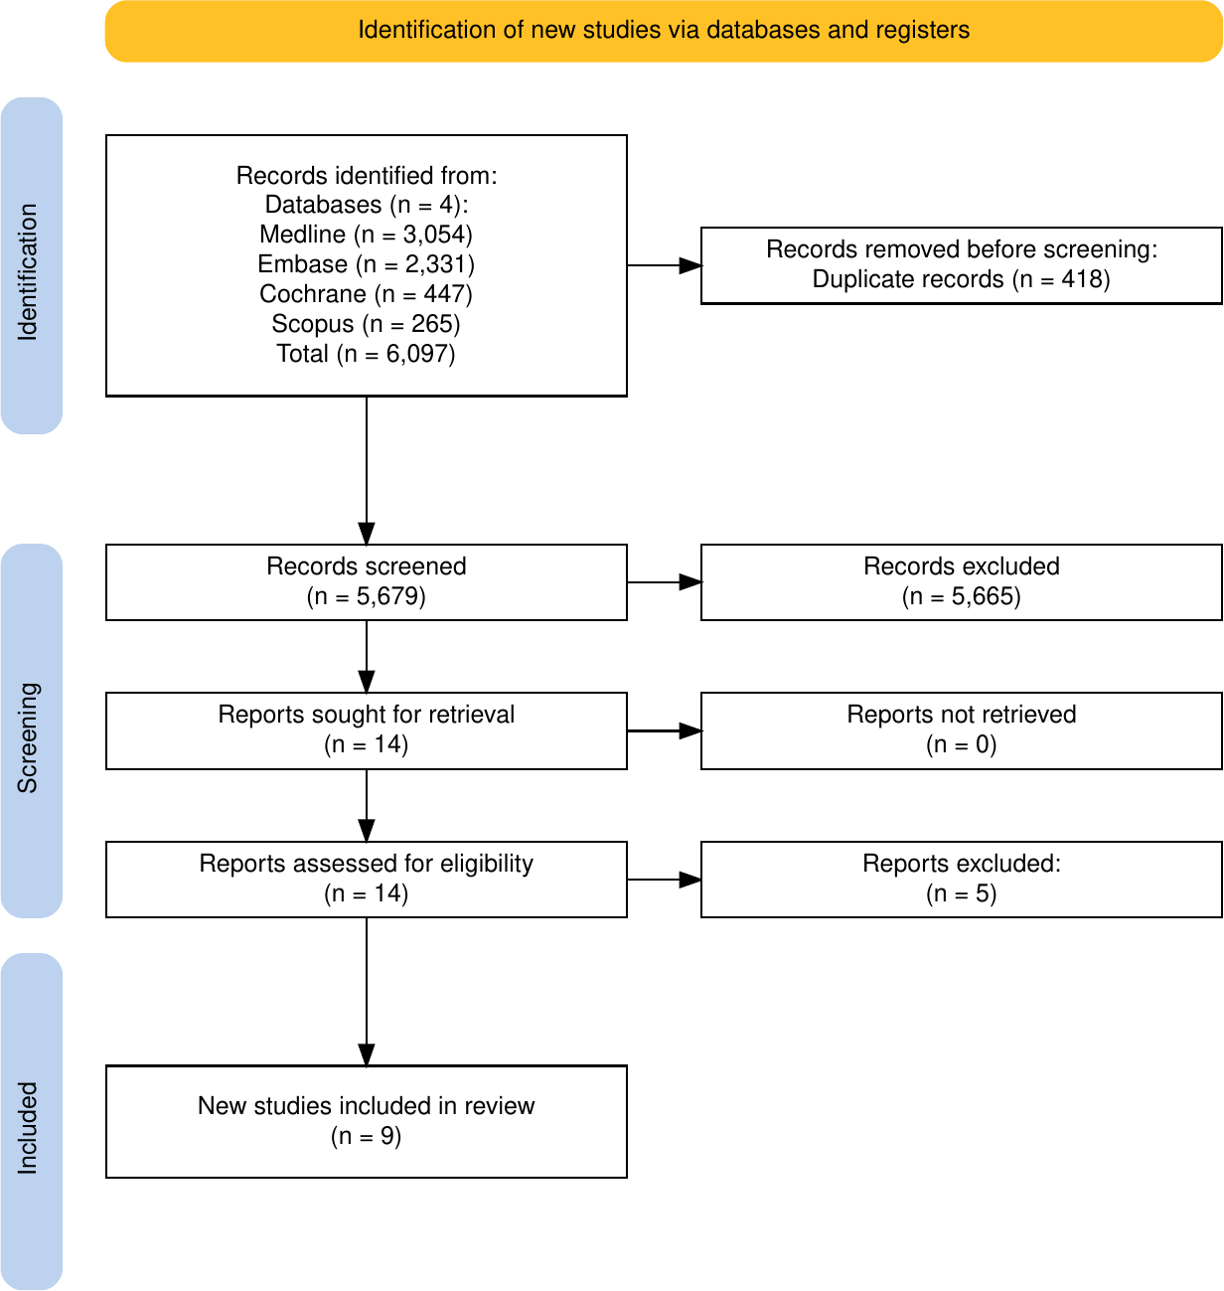
Figure 1. PRISMA 2020 flow diagram of study identification, screening and inclusion.

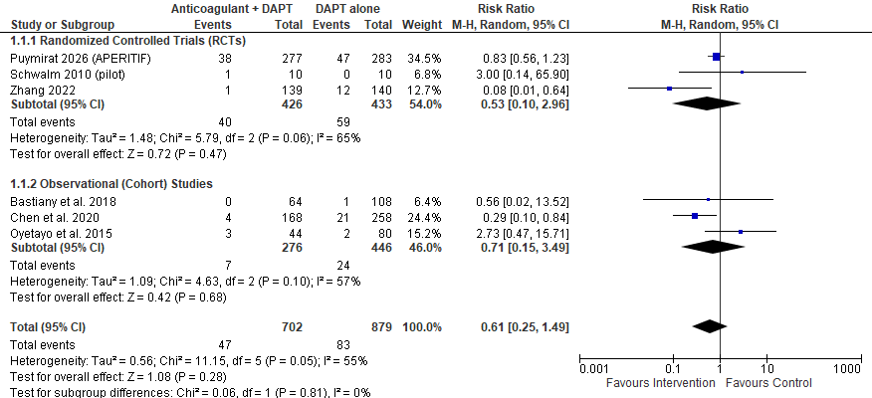
Figure 2. Forest plot of left ventricular thrombus formation (primary outcome), with subgroup analysis by study design. Random-effects model; risk ratio <1 favours anticoagulation. Pooled RR 0.61 (95% CI 0.25–1.49); I² = 55%; test for subgroup differences P = 0.81. The pooled reduction in LVT formation was not statistically significant (95% CI crosses 1).
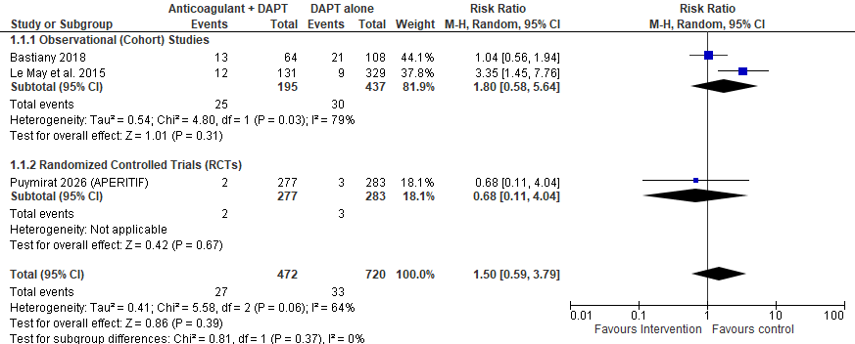
Figure 3. Forest plot of major adverse cardiovascular events, with subgroup analysis by study design. Pooled RR 1.50 (95% CI 0.59–3.79); I² = 64%; test for subgroup differences P = 0.37. The pooled difference in MACE was not statistically significant (95% CI crosses 1).

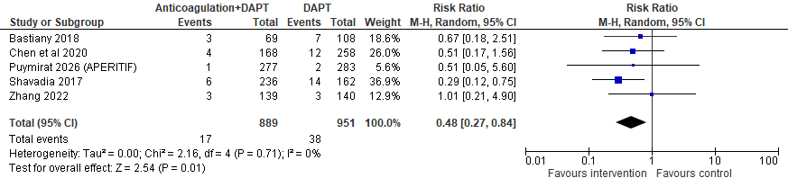
Figure 4. Forest plot of all-cause mortality. Pooled RR 0.48 (95% CI 0.27–0.84); I² = 0%. The pooled reduction in all-cause mortality was statistically significant (95% CI excludes 1).
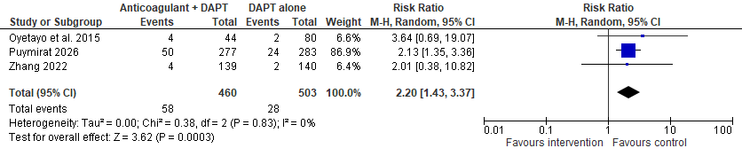
Figure 5. Forest plot of any (total) bleeding events. Pooled RR 2.20 (95% CI 1.43–3.37); I² = 0%. The pooled increase in any (total) bleeding was statistically significant (95% CI excludes 1).
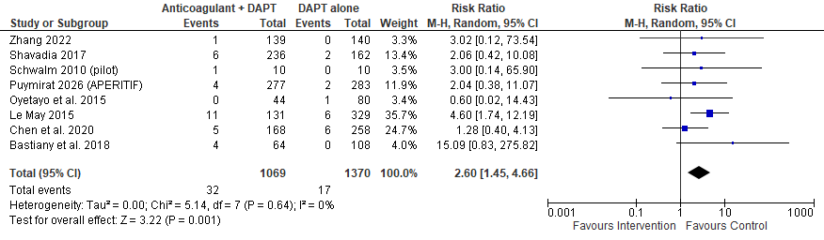
Figure 6. Forest plot of major bleeding. Pooled RR 2.60 (95% CI 1.45–4.66); I² = 0%. The pooled increase in major bleeding was statistically significant (95% CI excludes 1).

SUPPLEMENTARY FIGURES
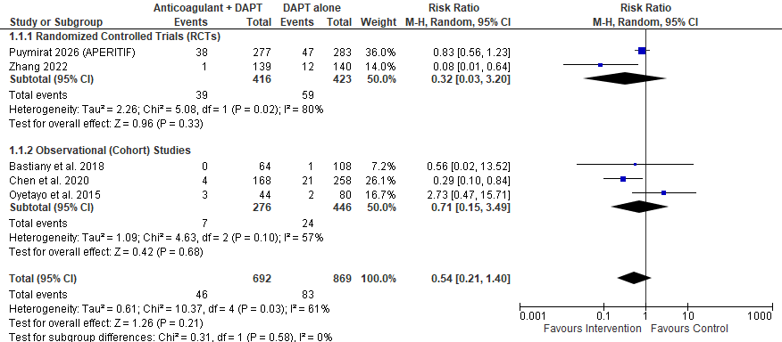
Supplementary Figure S1. Sensitivity analysis of left ventricular thrombus formation excluding the Schwalm 2010 pilot trial. Pooled RR 0.54 (95% CI 0.21–1.40); I² = 61%. The pooled estimate was not statistically significant (95% CI crosses 1).
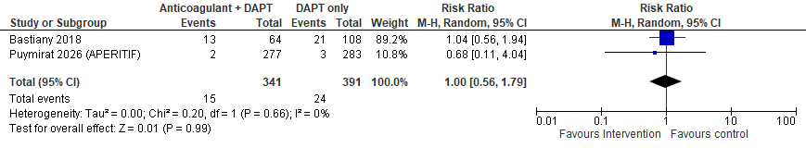
Supplementary Figure S2. Sensitivity analysis of major adverse cardiovascular events excluding Le May 2015. Pooled RR 1.00 (95% CI 0.56–1.79); I² = 0%. The pooled estimate was not statistically significant (95% CI crosses 1).

